### 



User Guide

Văn Lang Admissions

# Revision Table

|  |  |  |  |
| --- | --- | --- | --- |
| Author | Date | Reason for changes | Version |
| Khoi Nguyen | 11/05/2017 | Initial the document | 1.0 |
| Minh Doan  Khoi Nguyen | 12/05/2017 | Manage Account & Manage Category  Website , Manage News & Manage FAQ | 1.1 |
| Minh Doan  Khoi Nguyen | 13/05/2017 | Manage Banner  Summary | 1.2 |

Table of Contents

Revision Table 1

1. Website 5

2. CMS Page 13

2.1 Manage Account 13

2.1.1 Login 13

2.1.2 Logout 15

2.1.3 Create Account 16

2.1.4 View List Account 19

2.1.5 Edit Account 20

2.1.6 Search Account 22

2.1.7 View Detail of Account 23

2.1.8 Authorize 24

2.1.9 Deactivate Account 26

2.1.10 Activate Account 27

2.1.11 Forget Password 28

2.2 Manage News 30

2.2.1 View News in CMS page 30

2.2.2 View Draft 31

2.2.3 Create Draft 31

2.2.4 Edit Draft 33

2.2.5 Delete Draft 34

2.2.6 Transfer Draft 36

2.2.7 Approve Draft 37

2.2.8 Post News 38

2.2.9 Deactive News 39

2.2.10 Push News 41

2.2.11 Unpush News 42

2.3 Manage Category 43

2.3.1 View List of Categories in CMS page 43

2.3.2 Create Category 45

2.3.3 Create Categories Level 2 47

2.3.4 Edit Category 49

2.3.5 Delete Category 51

2.4.1 View FAQ 53

2.4.2 Answer Question 53

2.4.3 Approve Question 55

2.5 Manage Banner 56

2.5.1 View Banner in CMS page 56

2.5.2 Create Banner 57

2.5.3 Edit Banner 60

2.5.4 Delete Banner 63

2.5.5 Show Banner 64

2.5.6 Hide Banner 65

2.5.7 Arrange Images 66

# Website

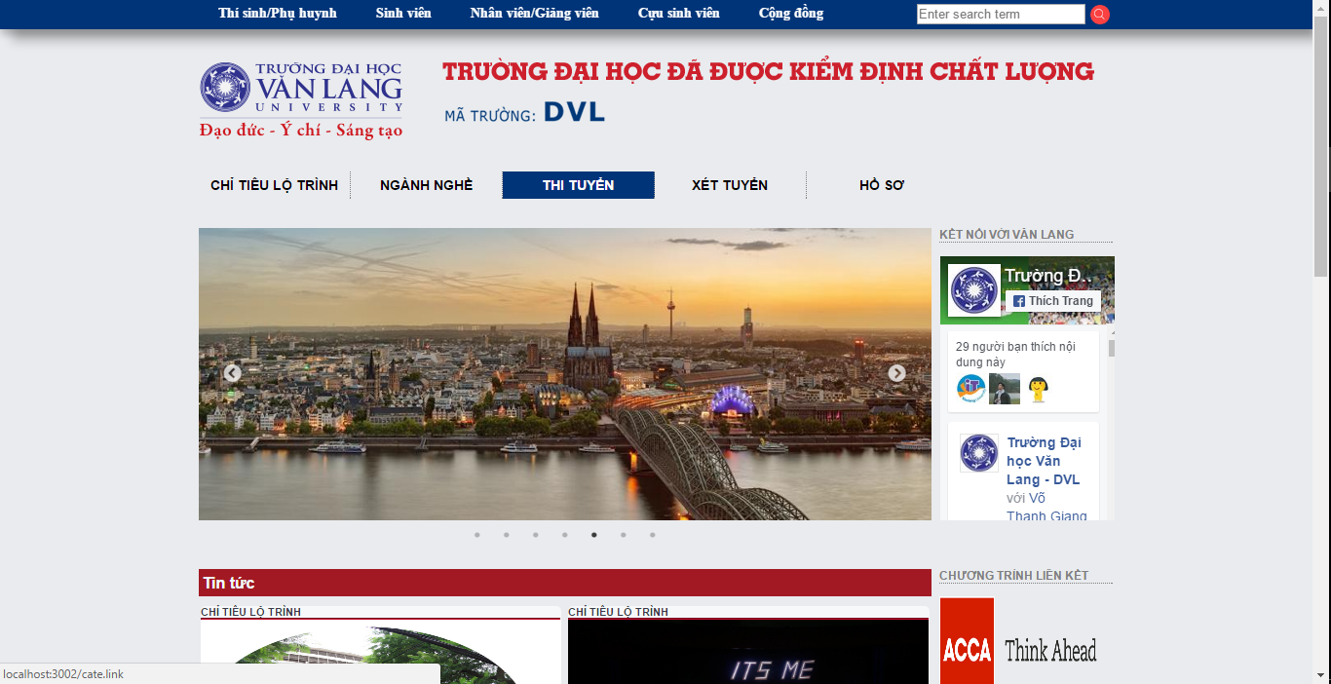

Picture 1: Homepage of VanLang Admission

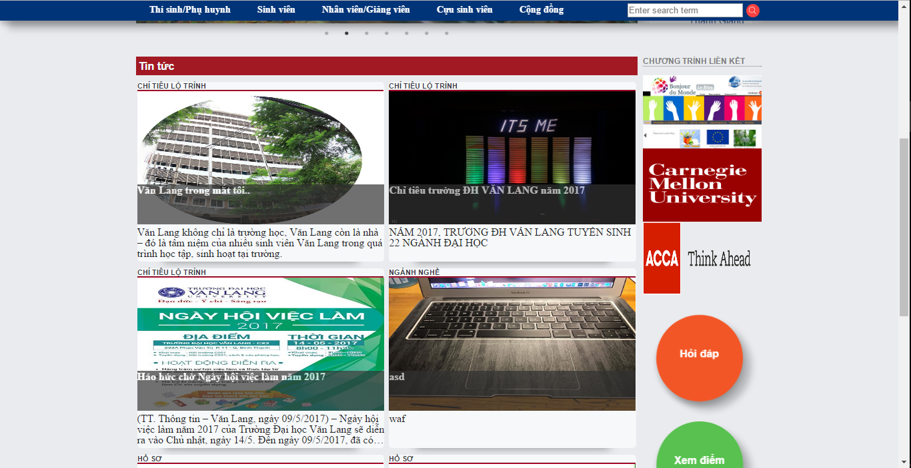

Picture 2: News & function FAQ , View Point

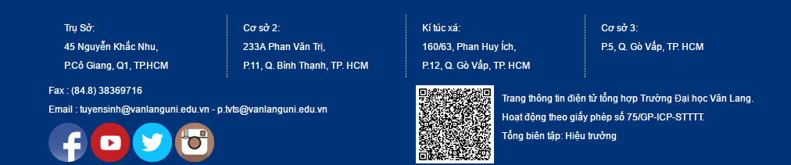

Picture 3: Information of Van Lang University

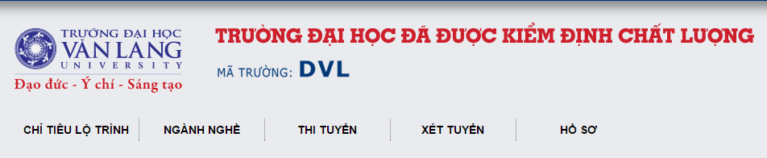

Picture 4: Logo, School code & Categories

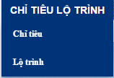

Picture 5 : When pointing of each category , many sub-categories will bi display for user to select

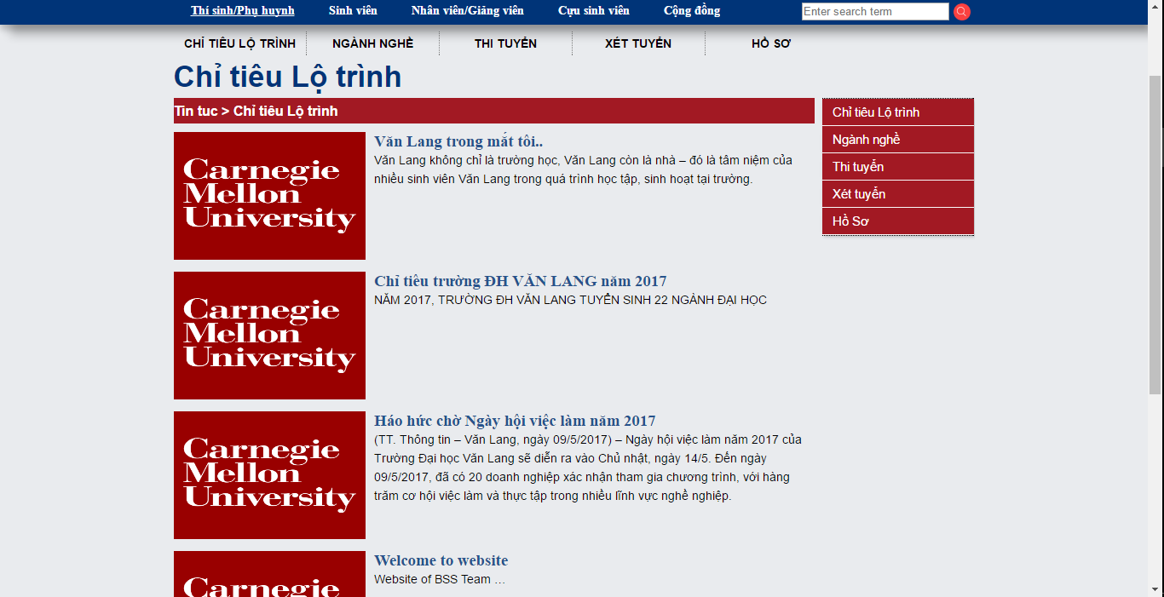

Picture 6: List news of each category

* The latest news will be pushed to the top of the list
* On the right of the news list there are also sub-categories
* 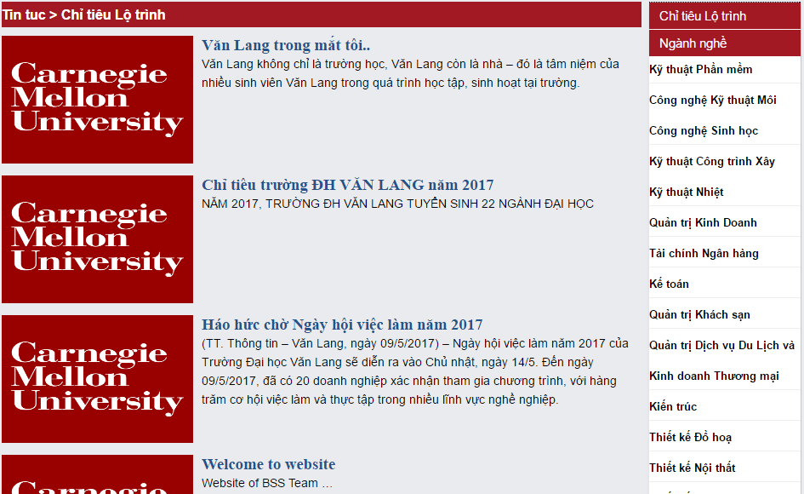

Picture 7: List sub-categories of “Ngành nghề” category

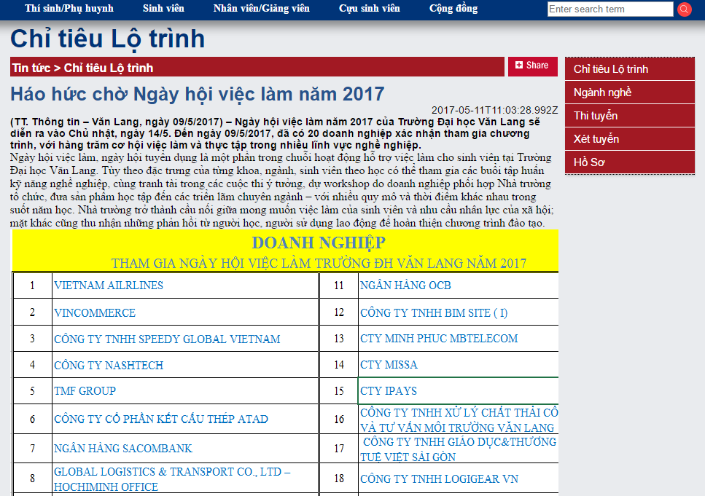

Picture 8: Detail of news

* When user click on news , system will display detail of this news
* Button “Share” in the right allows users to share this news to other people through social networks such as Facebook , Twitter , Google + …

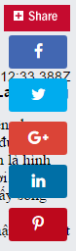

Picture 9: The social network for users to choose to share

* Below the news , there are some other related news

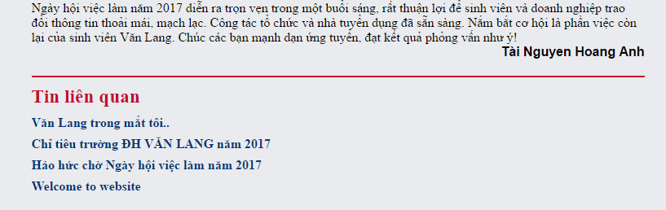

Picture 10: List of related news

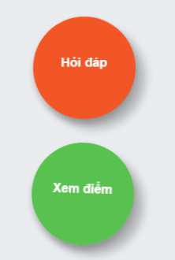

Picture 11: Two function : FAQ & View Point

* When clicking on the View Point button , System will display Point Lookup Interface
* 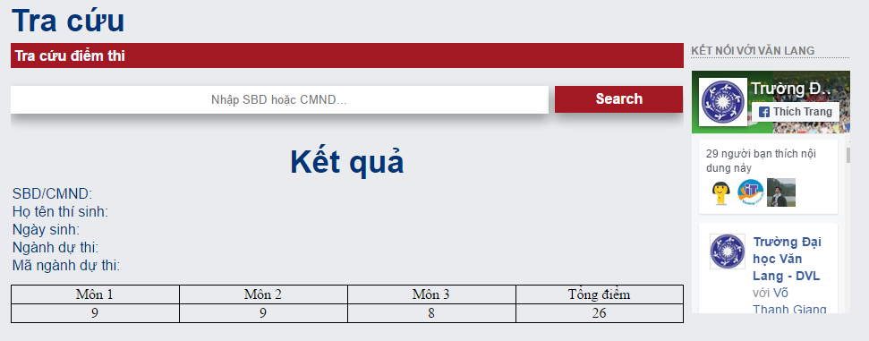

Picture 12: Point Lookup Interface

* Students enter their Exam ID or ID number , click button “Search” & their information wil display
* About the function FAQ. When students - students want to see relevant questions that the school has already answered then click on the FAQ button

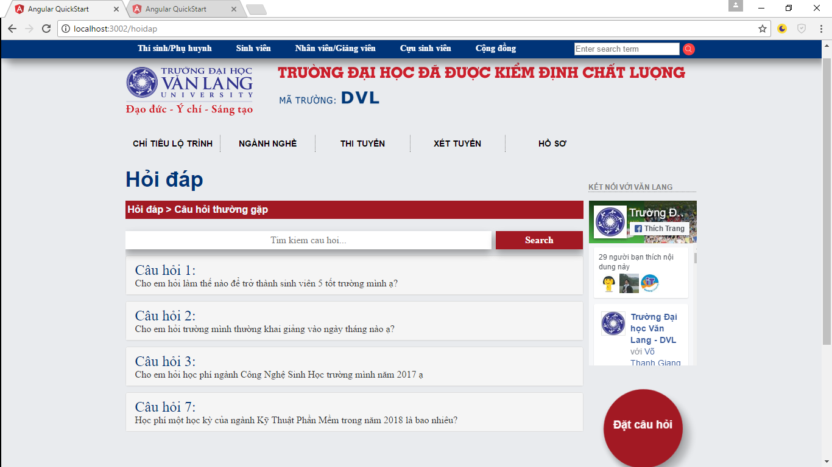

Picture 13: List of Frequently Asked Questions

* Click on the question to see the answer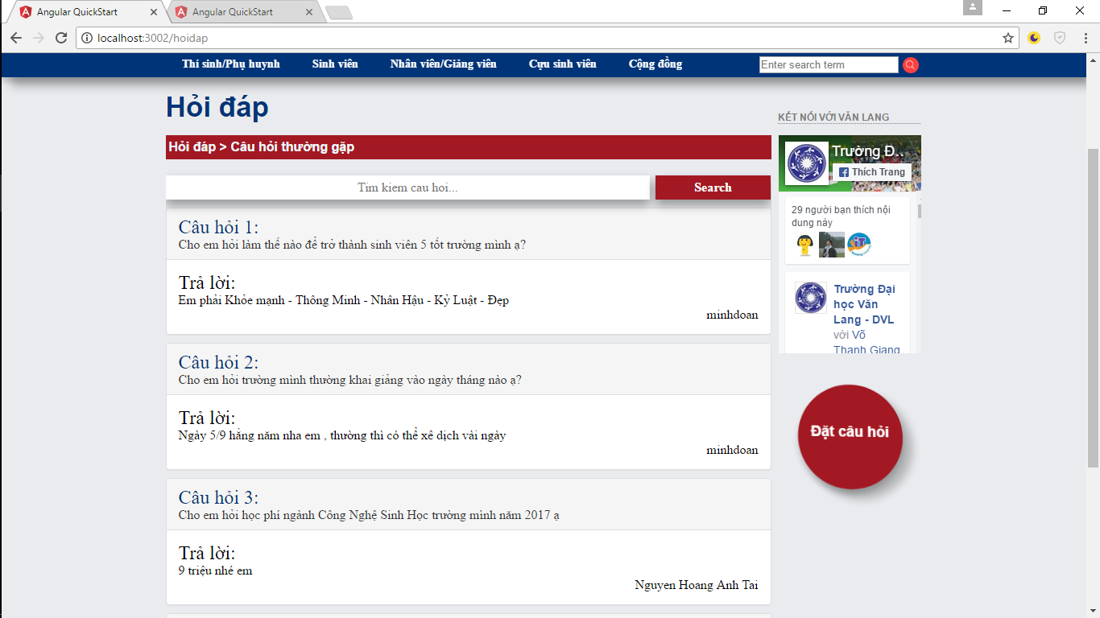

Picture 14: The answer below the question when the user clicked

- When you want to ask questions to the school, just click "Ask Question" on the right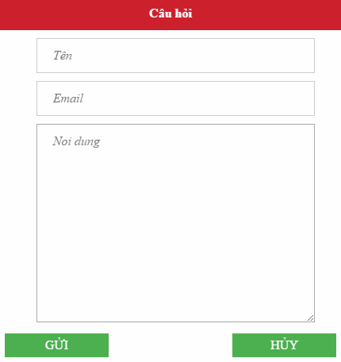

Picture 15: Ask question interface

* Input Full Name
* Input Email ( Correct format - @... )
* Input Question

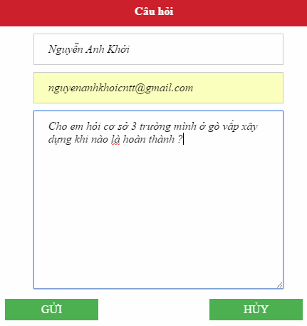

Picture 16: Ask question

* Click Send is done.

# CMS Page

* 1. Manage Account

### 2.1.1 Login

Step 1: access to CMS page.

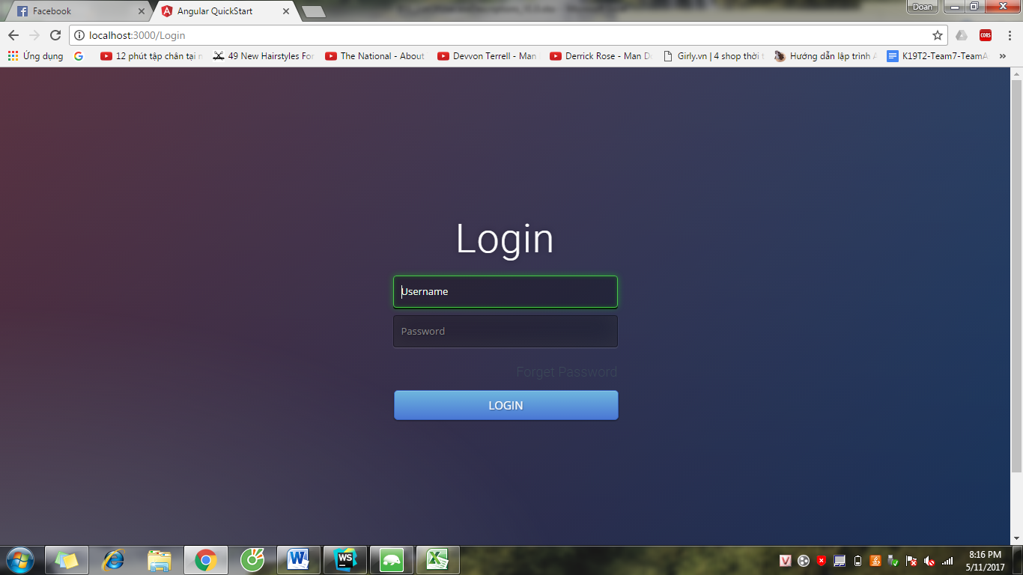

Step 2: Input Email and Password and click “LOGIN” button.

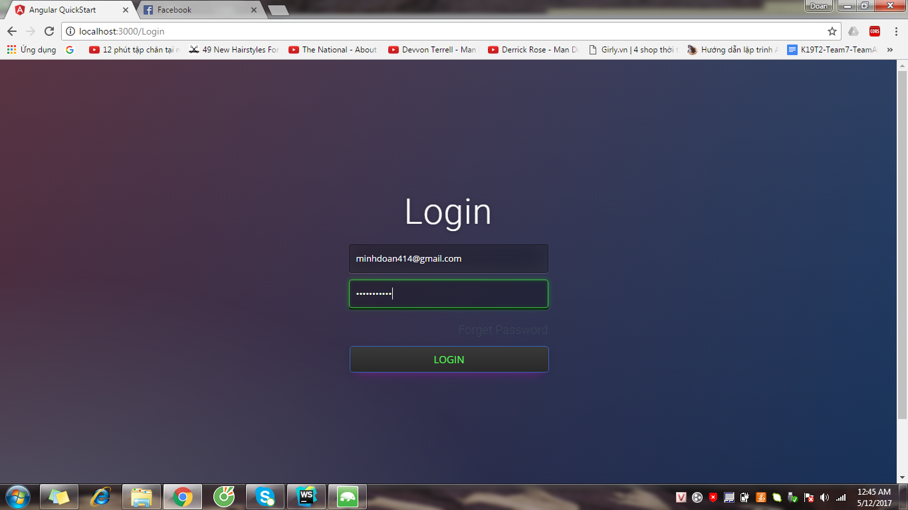

Step 3: System show CMS page.

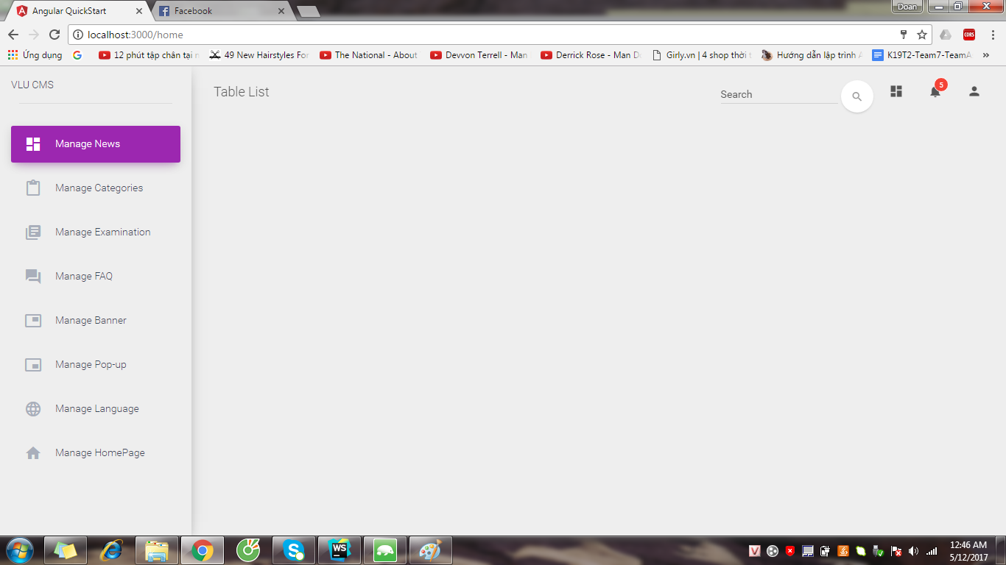

### 2.1.2 Logout

Step 1: Click button  and click “LOGOUT” button

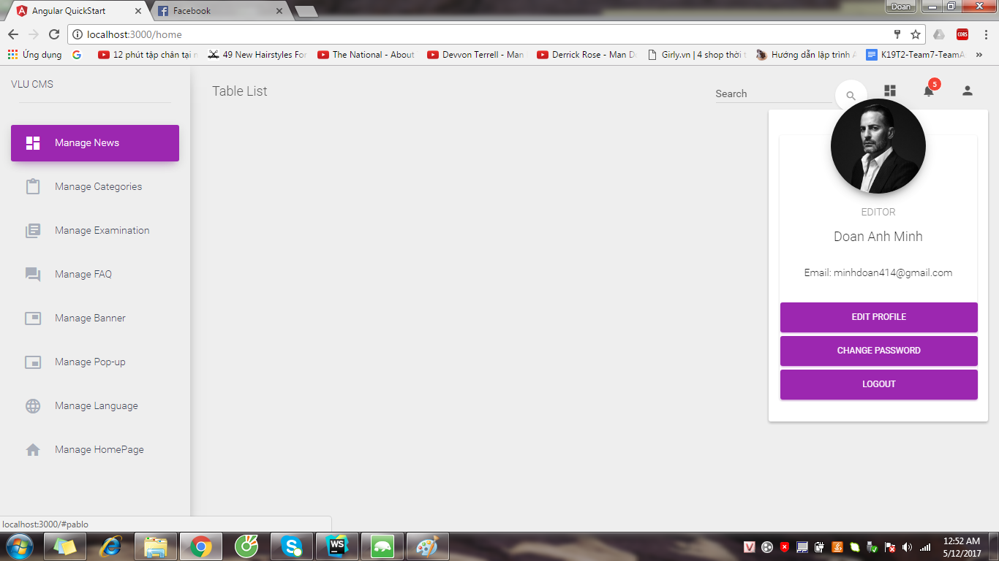

Step 2: System show LOGIN page

## 

### 2.1.3 Create Account

Step 1: Login to CMS page by System Admin account

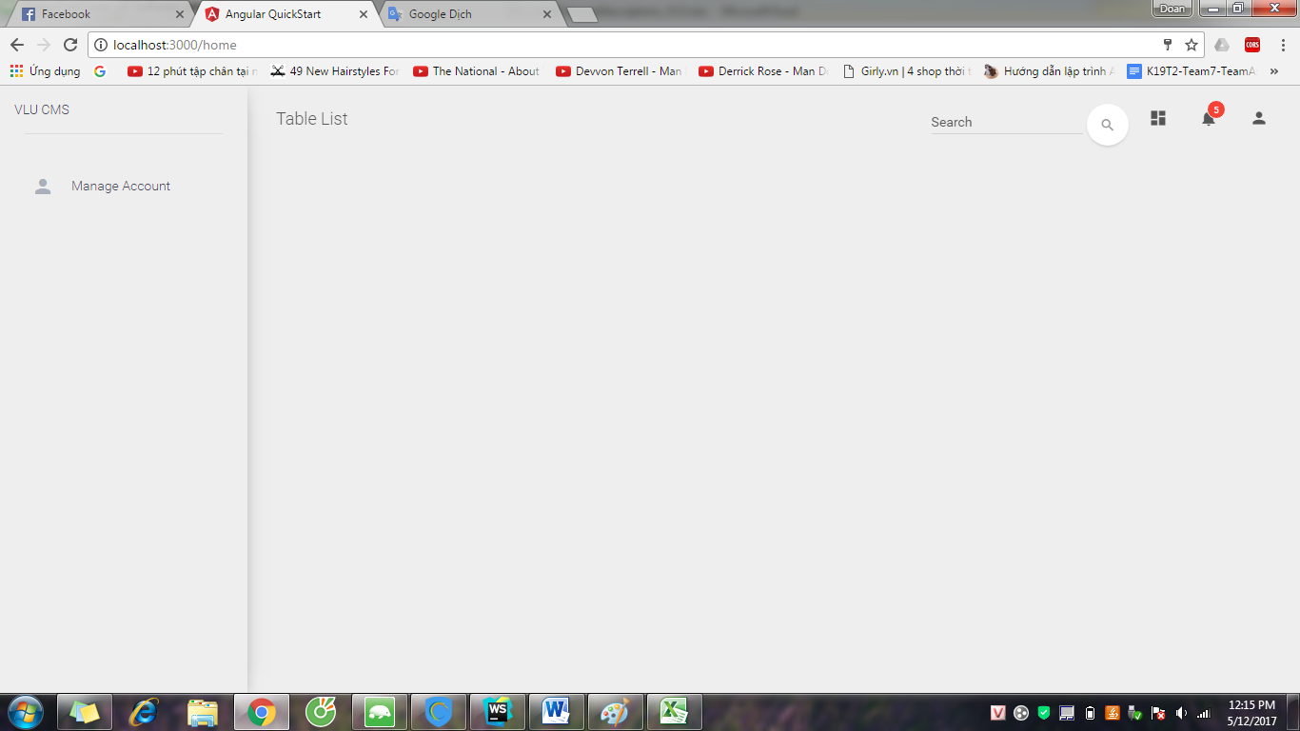

Step 2: Click Manage Account and click Create Account

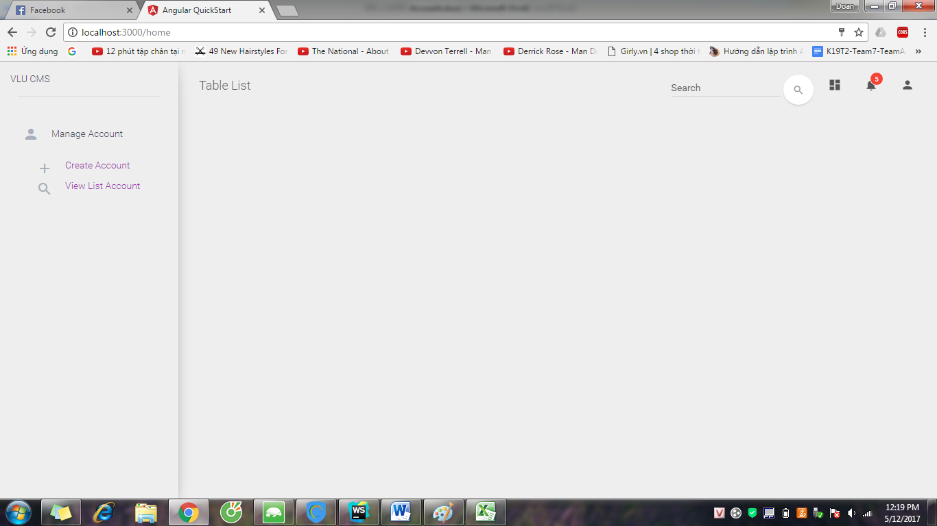

Step 3: System shows “Create Account” page.

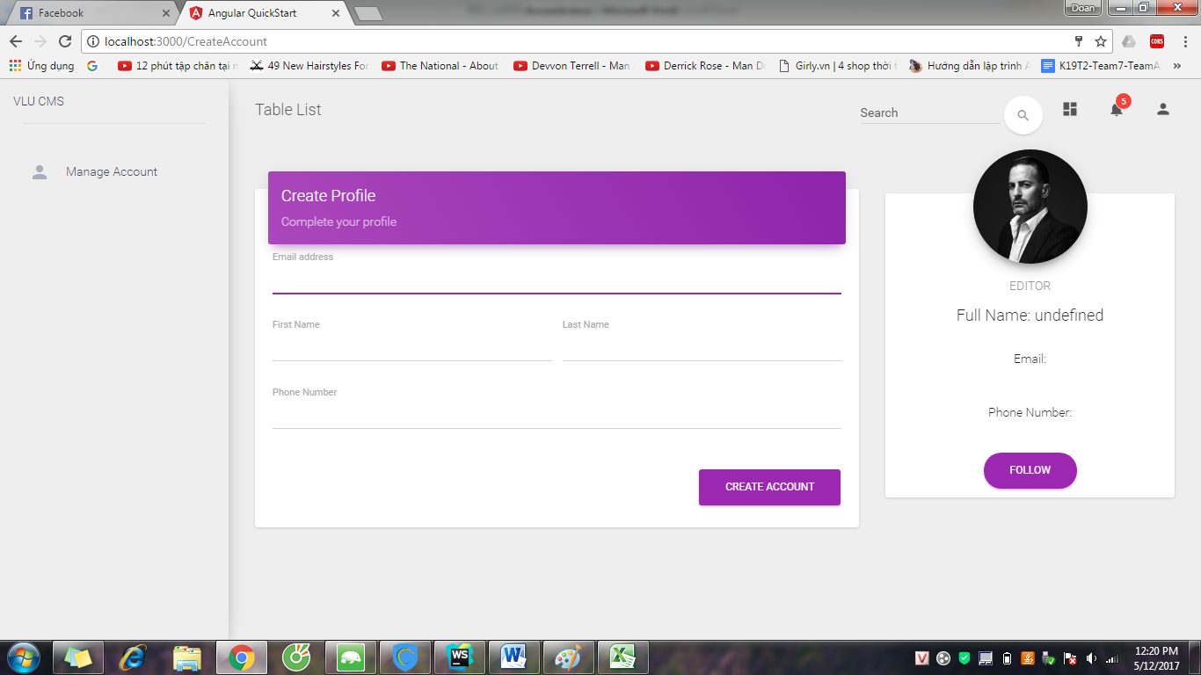

Step 4: Input full information of account and click “CREATE ACCOUNT” button

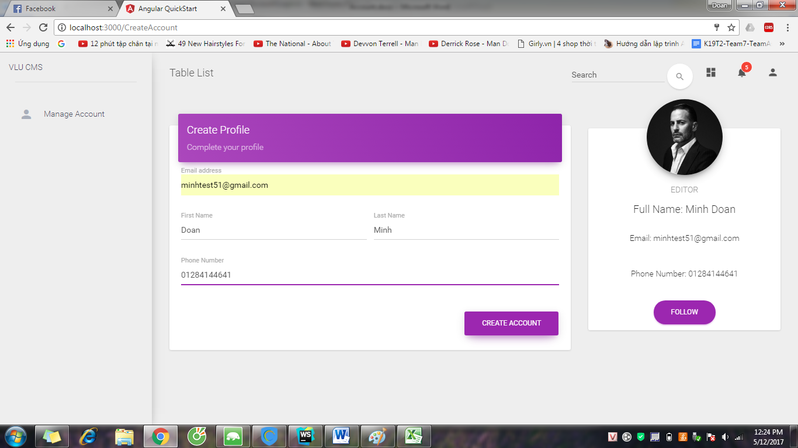

Step 5: System notifies success message and system send the message with password to email.

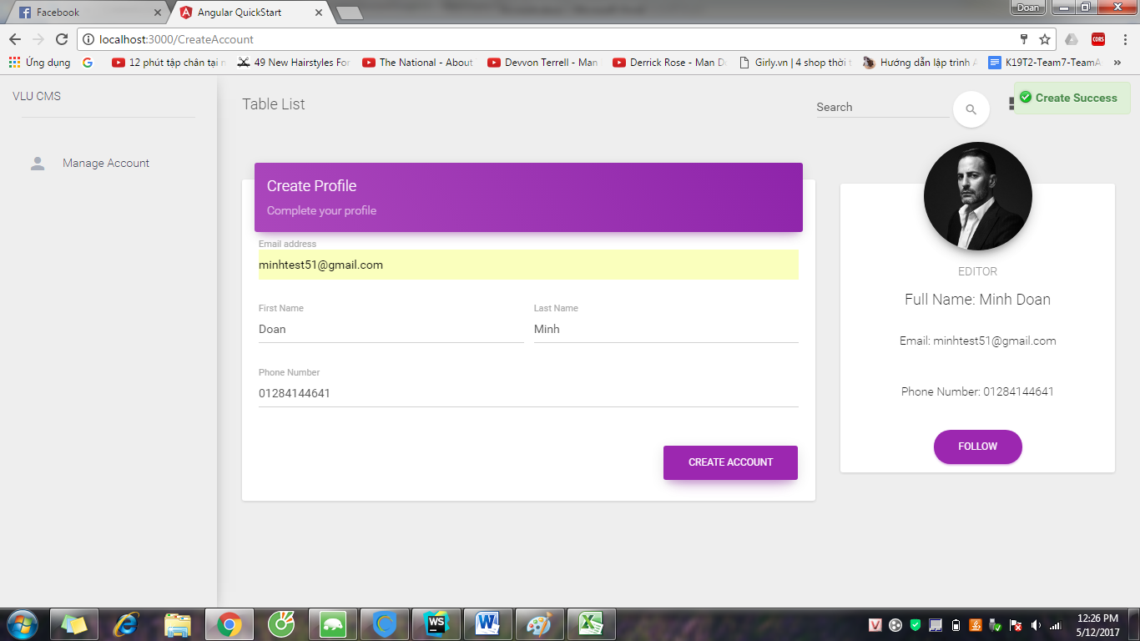

### 2.1.4 View List Account

Step 1: Login CMS page by System Admin account



Step 2: Click Manage Account and click View List Account

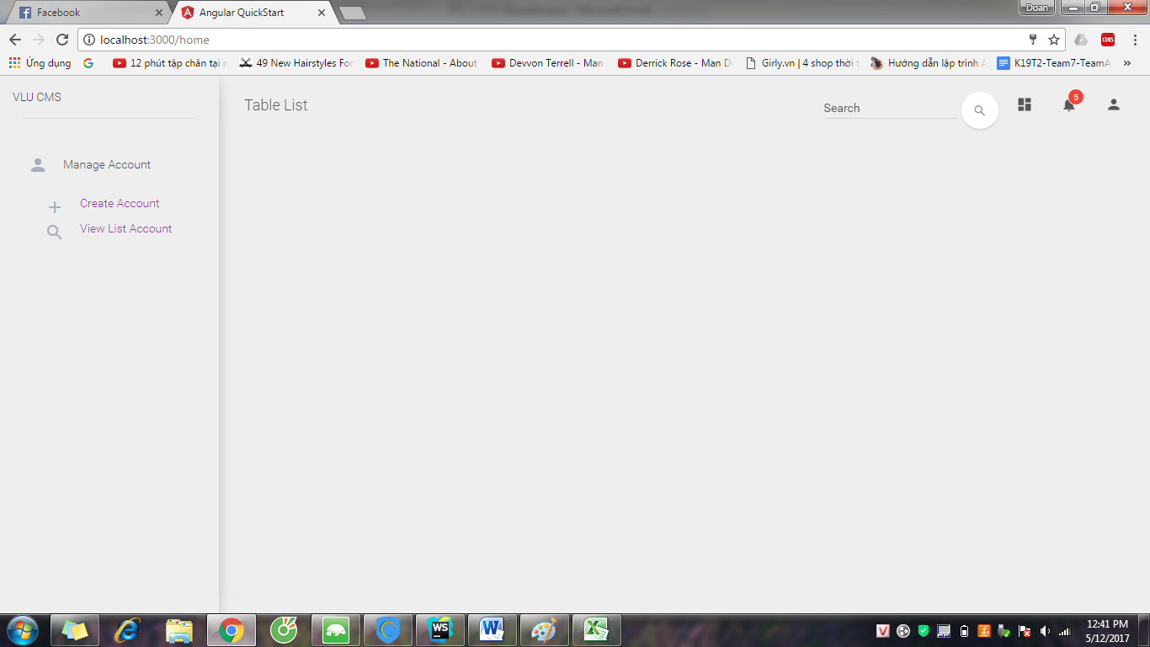

Step 3: System show List of accounts

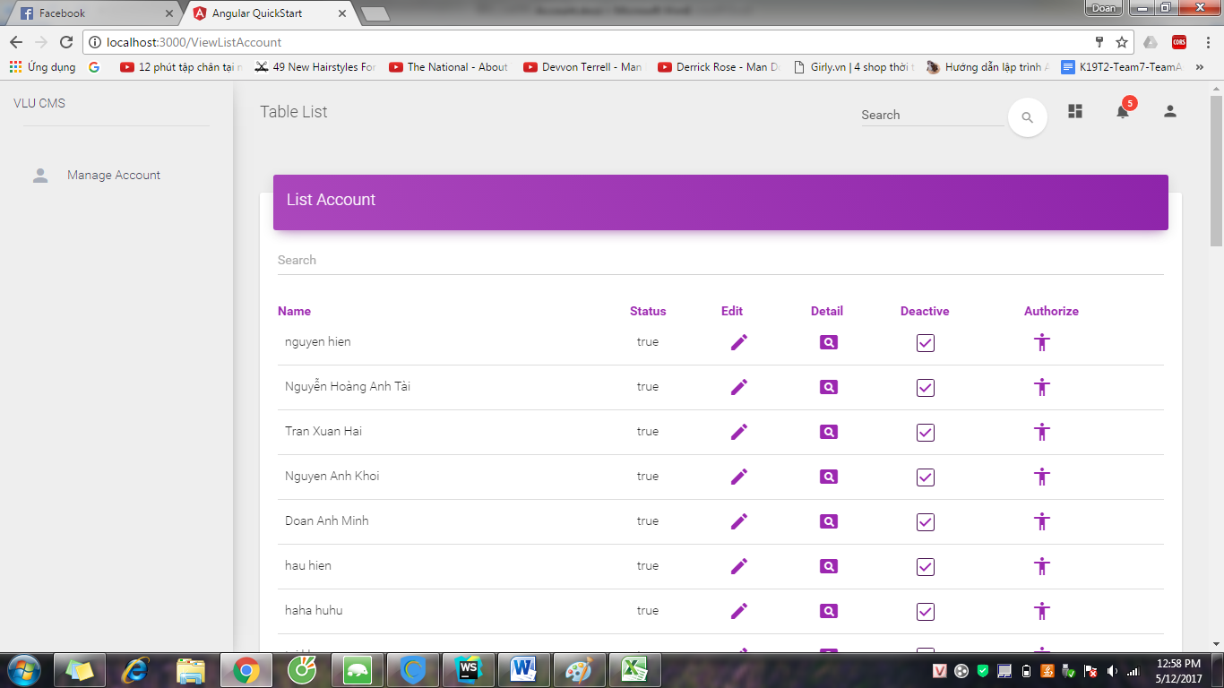

### 2.1.5 Edit Account

Step 1: Access to View List Account page, choose the account and click edit button



Step 2: System show “Edit Account” page

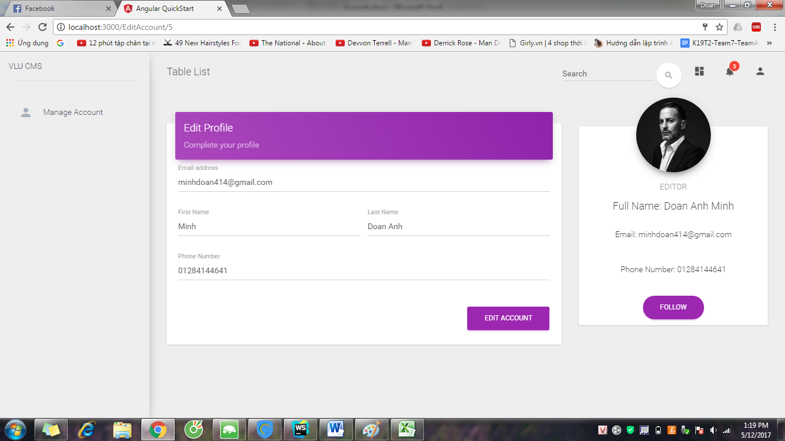

Step 3: Edit information of account except the Email

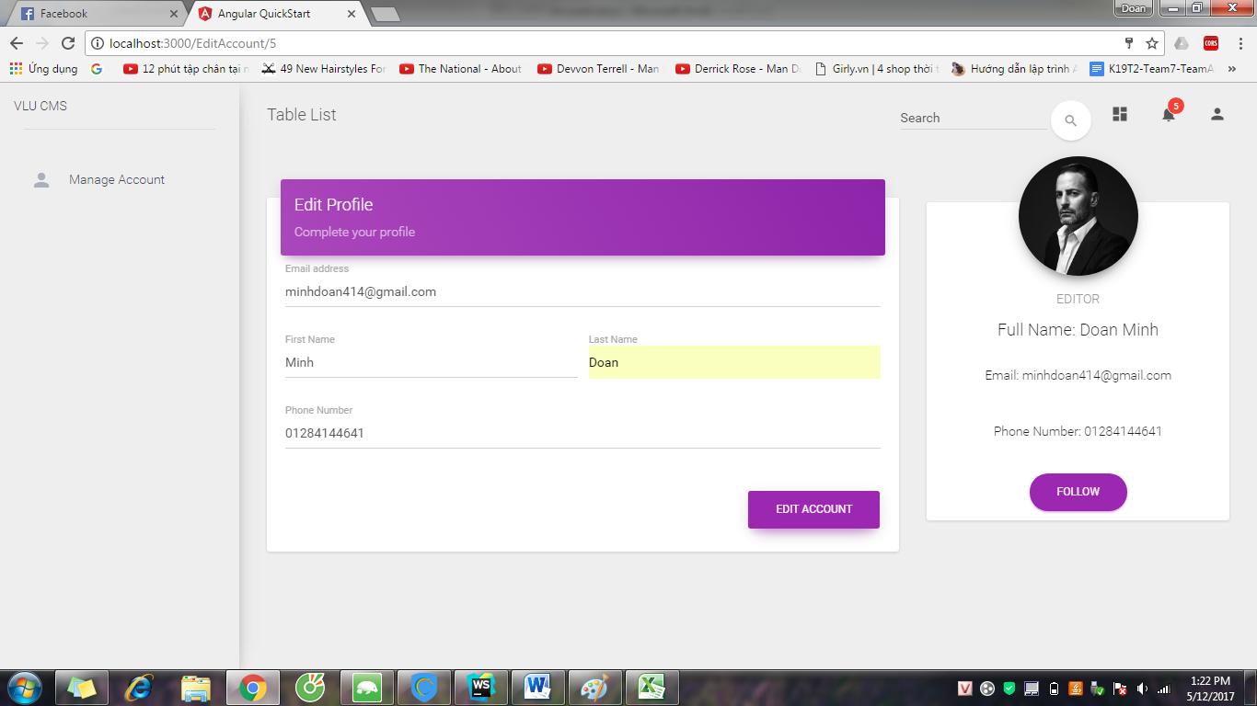

Step 4: System show success message

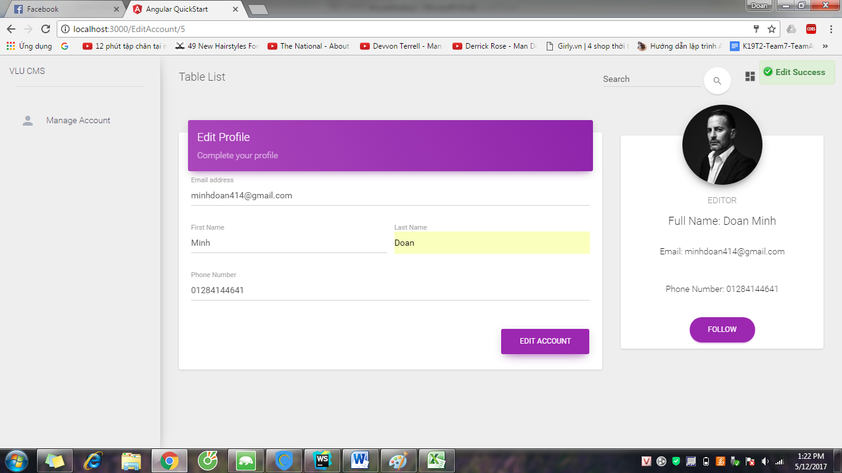

### 2.1.6 Search Account

Step 1: Access to View List Account page

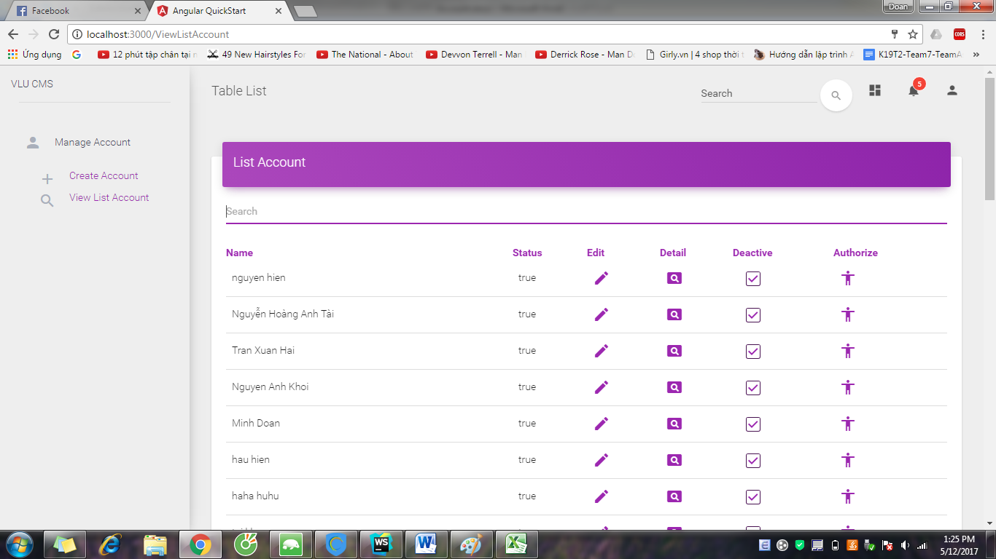

Step 2: Input name of account which you want to search and system show the account with the key search

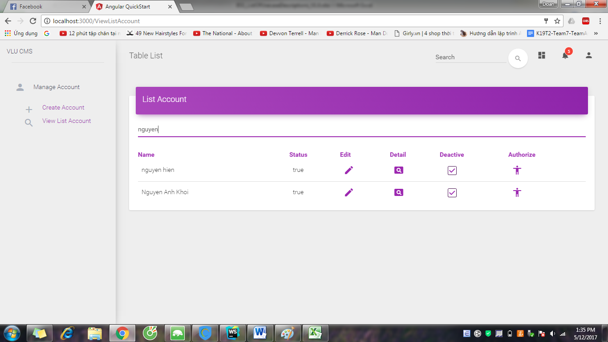

### 2.1.7 View Detail of Account

Step 1: Click  button in the CMS page



Step 2: System show detail of account



### 2.1.8 Authorize

Step 1: Access to View List Account, choose and click Authorize button



Step 2: System show Authorize form

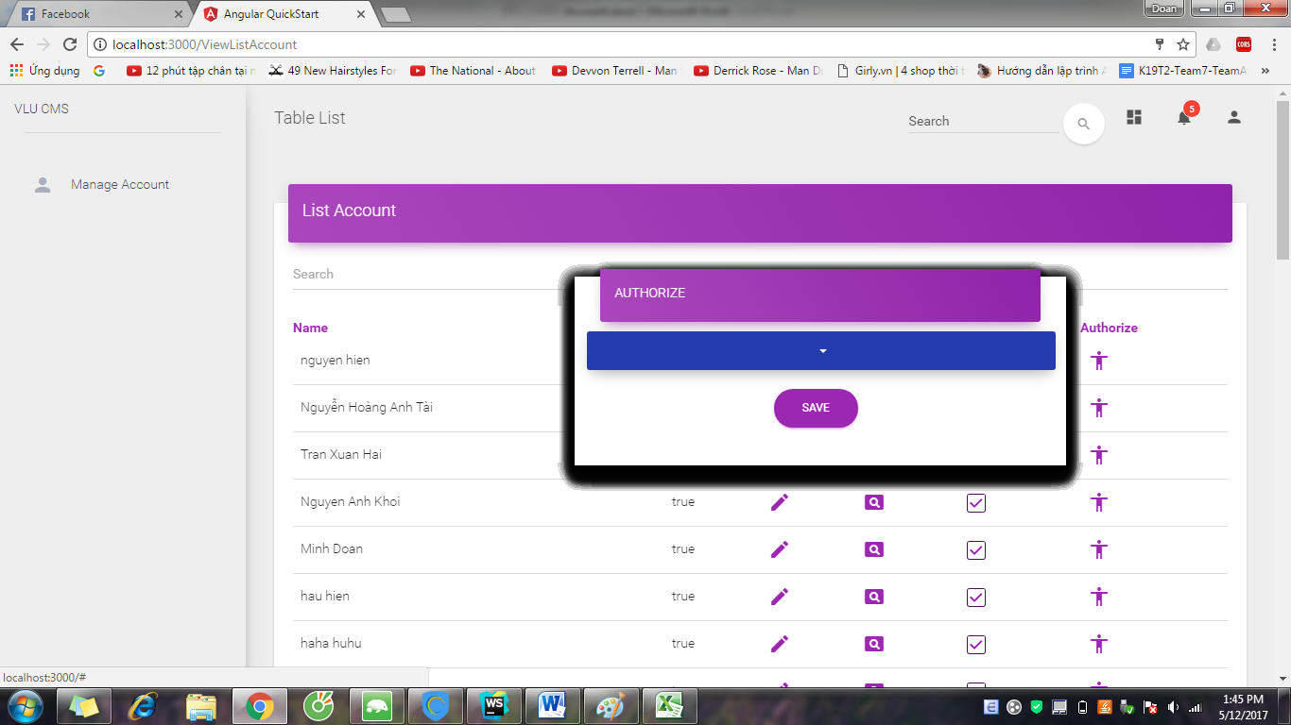

Step 3: Choose role for account and click “SAVE” button

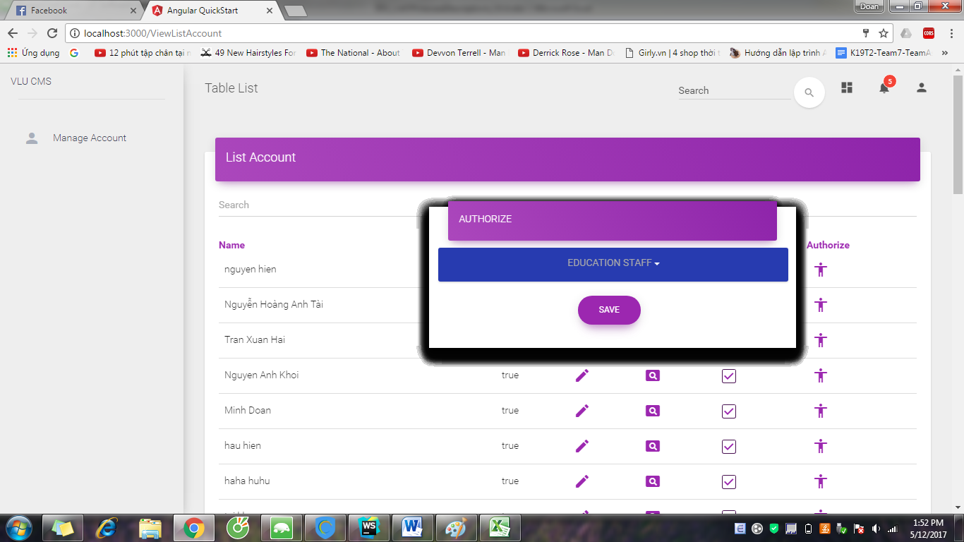

Step 4: System shows success message

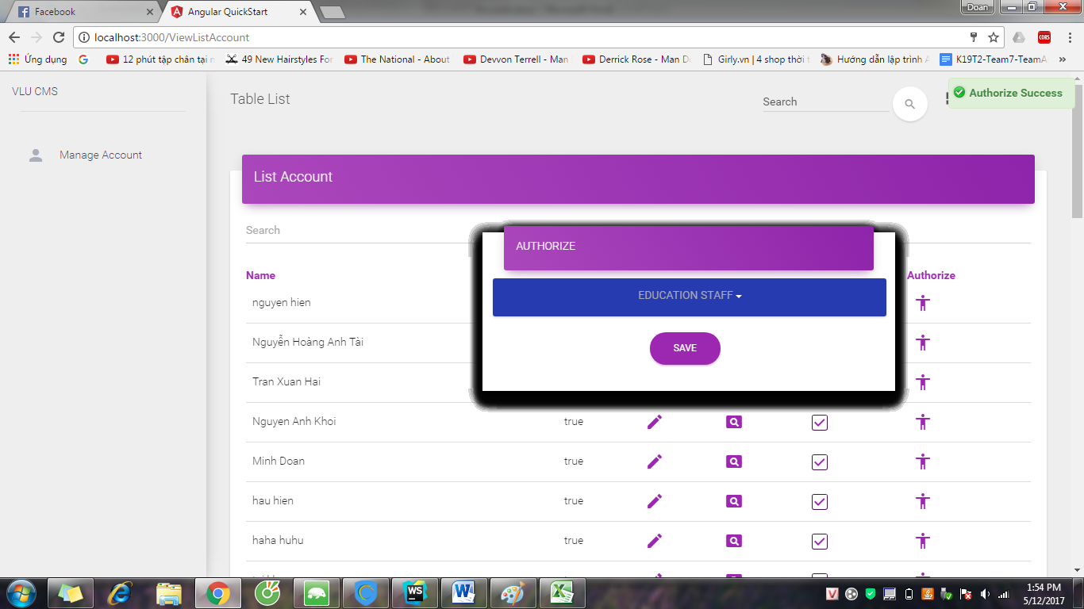

### 2.1.9 Deactivate Account

Step 1: Access to View List Account page



Step 2: Choose account and uncheck the “Deactive” button, System show the success message

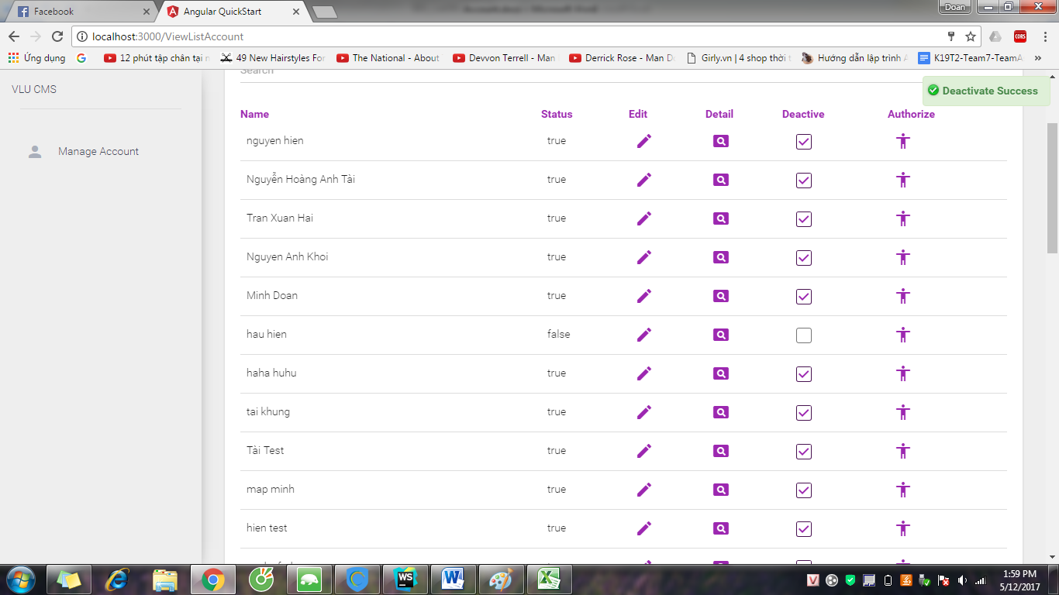

### 2.1.10 Activate Account

Step 1: Access to View List Account page

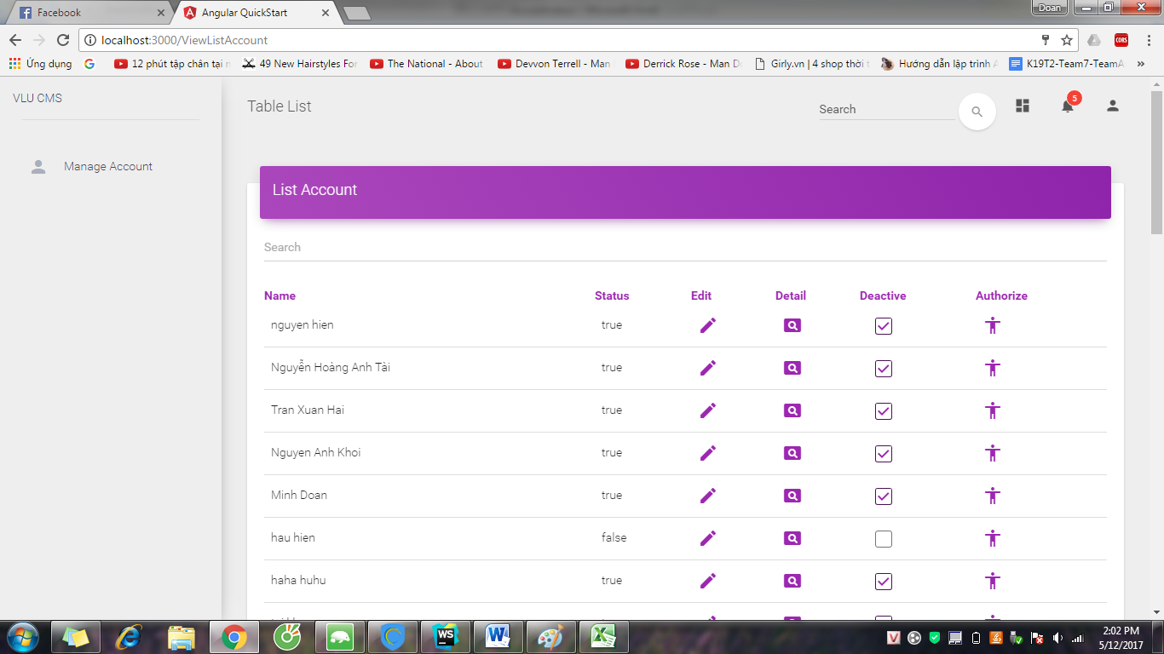

Step 2: Choose account and check the “Deactive” button, System show success message

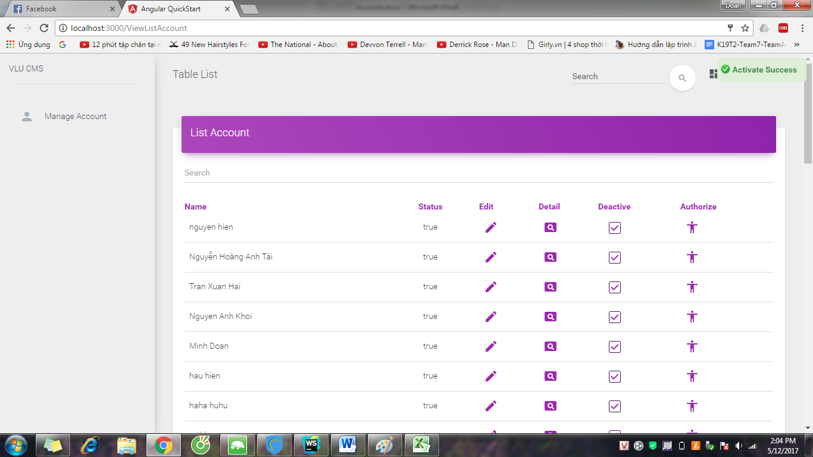

### 2.1.11 Forget Password

Step 1: Access to CMS page and click “Forget Password”



Step 2: System show “Forget Password” form

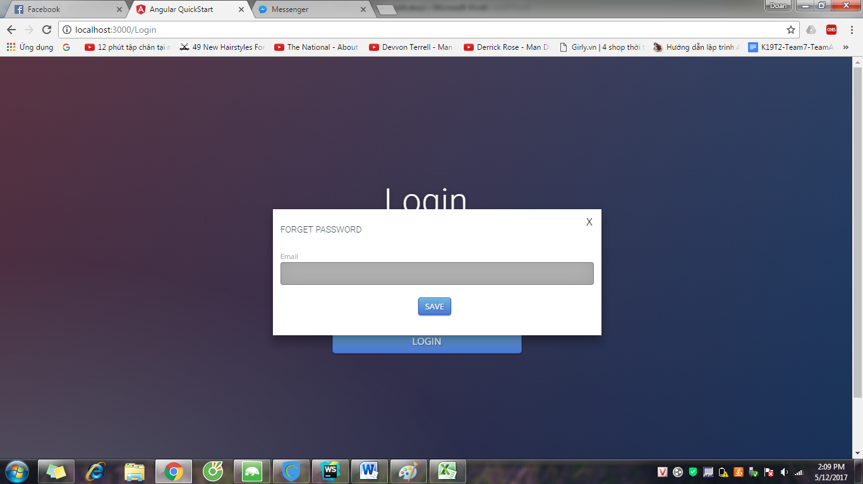

Step 3: Input Email and click “SAVE” button

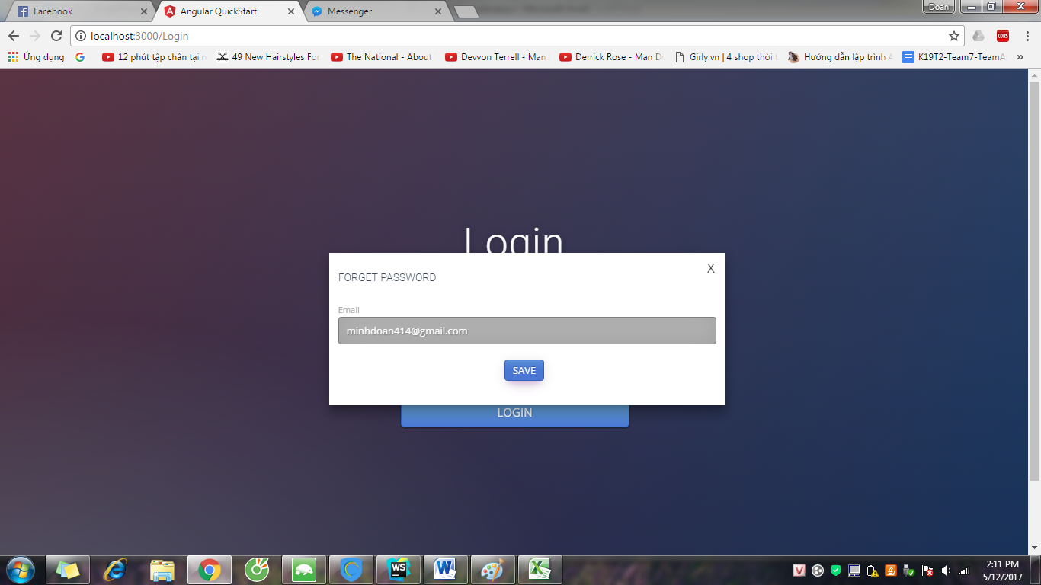

Step 4: System show success message and send new Password to Email.

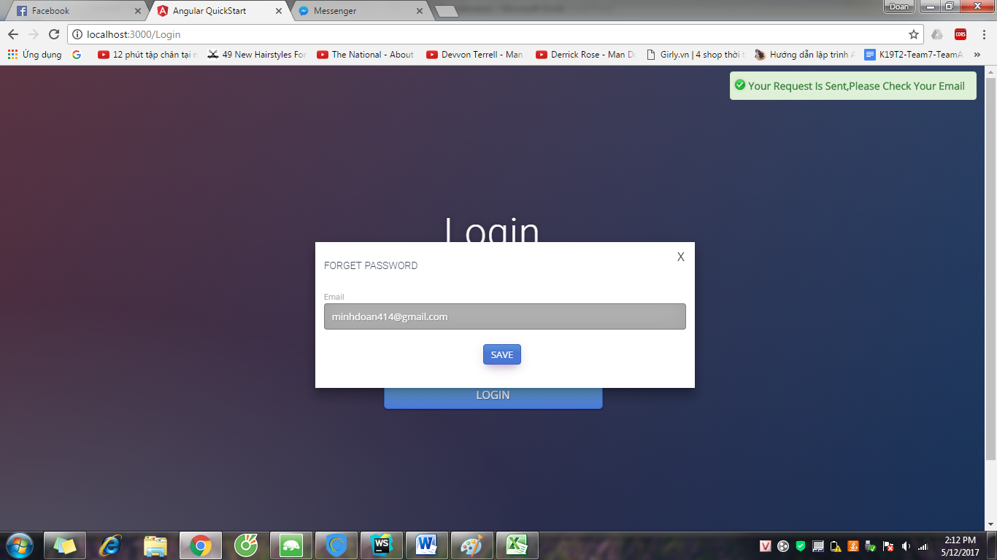

* 1. Manage News

### 2.2.1 View News in CMS page

Step 1: Login to CMS page

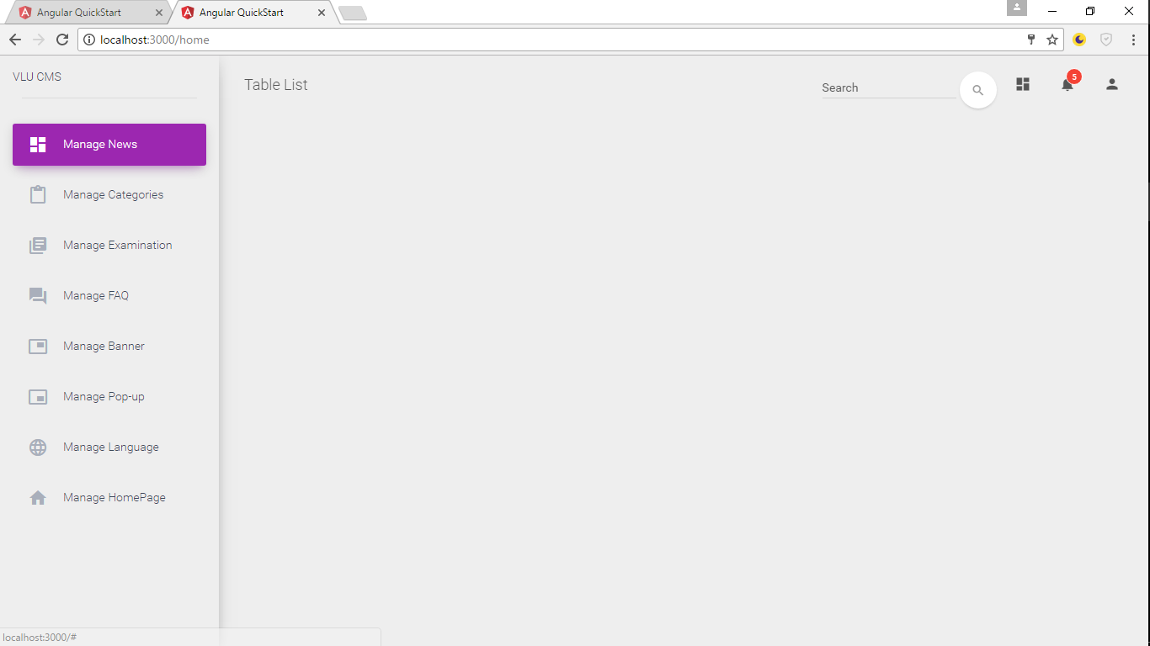

Step 2 : Click Manage News & click View News

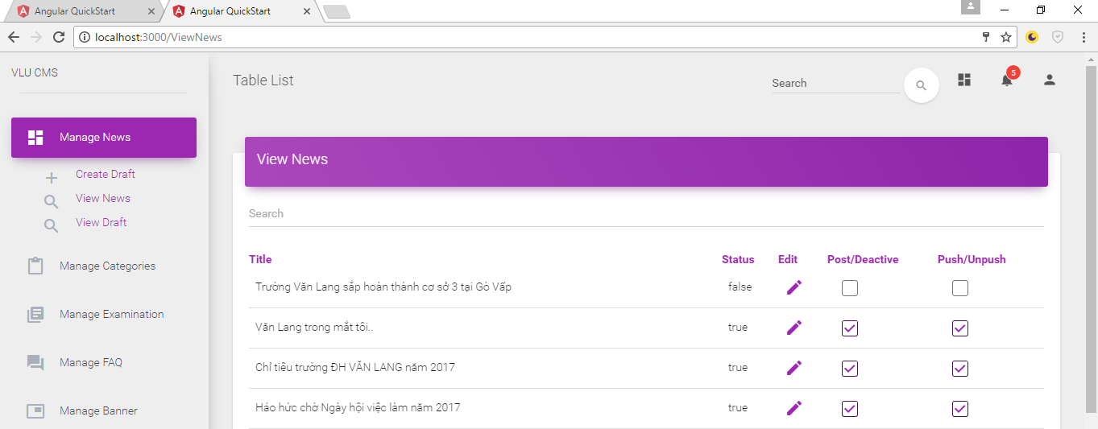

* + 1. View Draft

Step 1 : Click Manage News & click View Draft

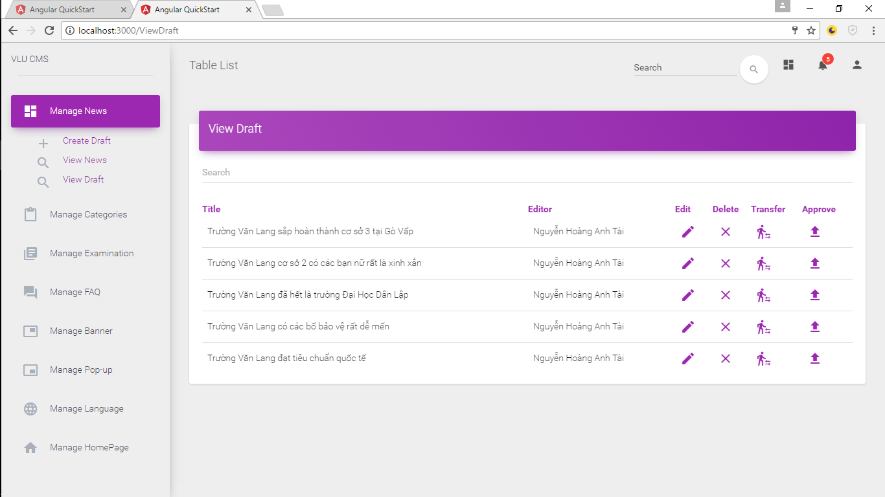

* + 1. Create Draft

Step 1: Click Manage News & click Create Draft

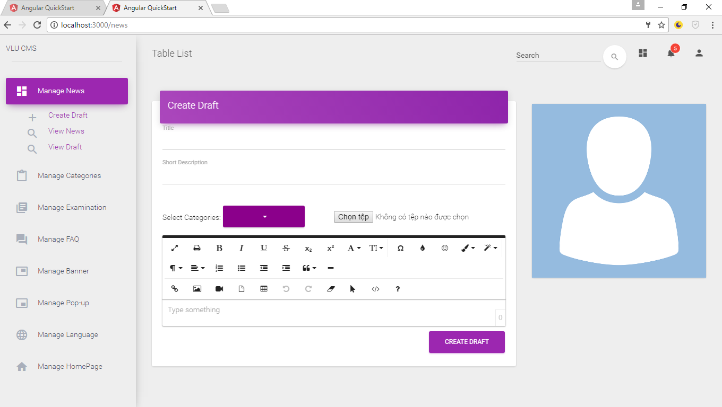

Step 2: Input Title , Short Description , Content , select categories & input Avatar

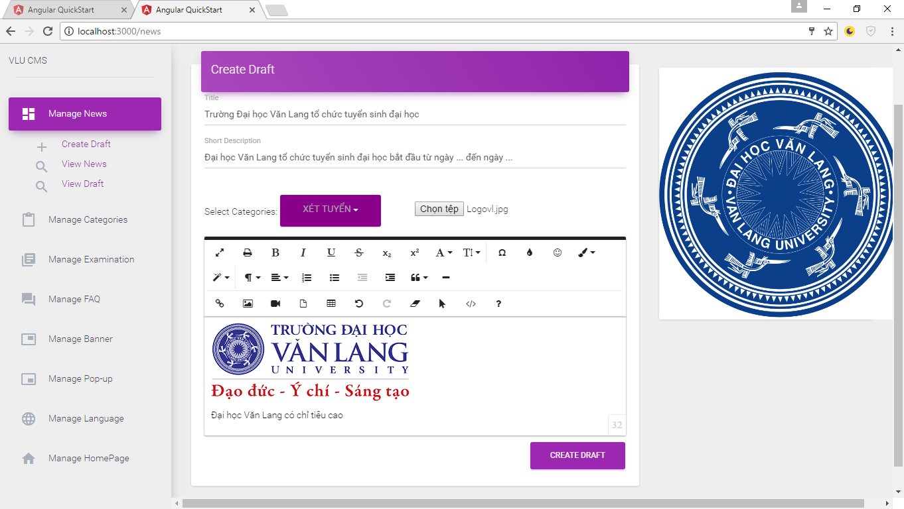

Step 3: Click button “Create Draft”

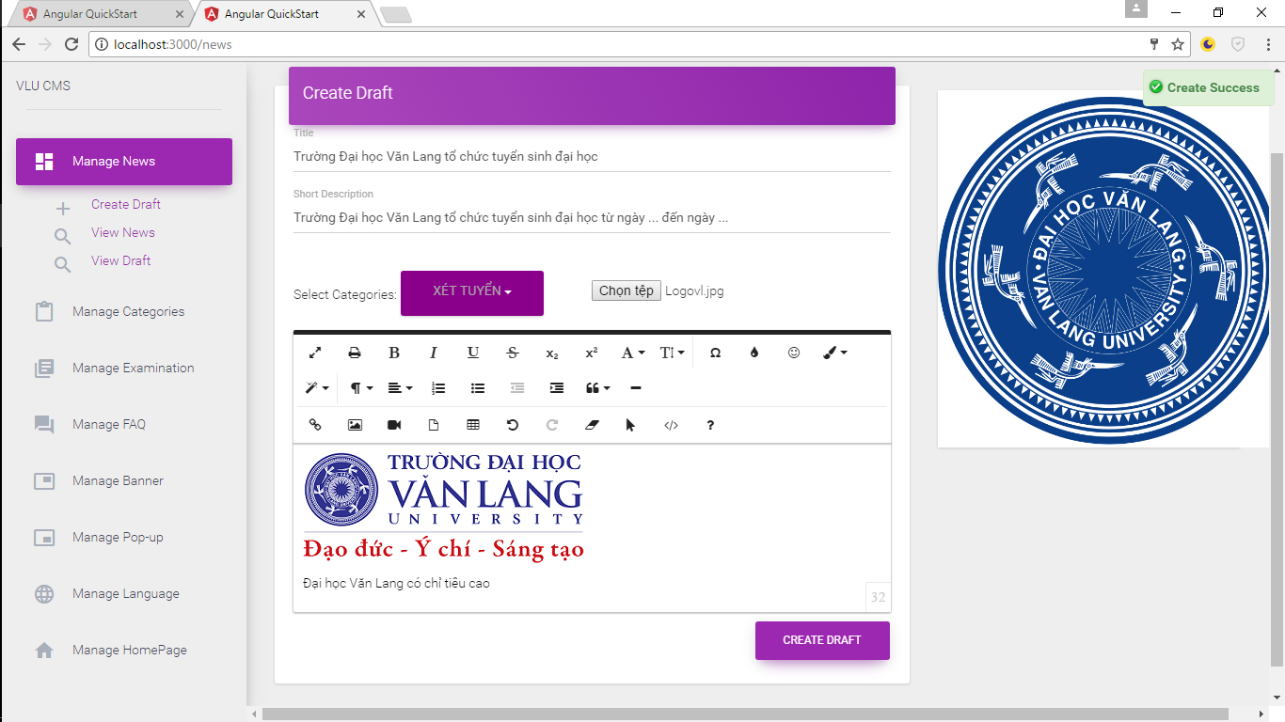

System show message “Create Success”

* + 1. Edit Draft

Step 1: Click View Draft , choose draft & click button “Edit”

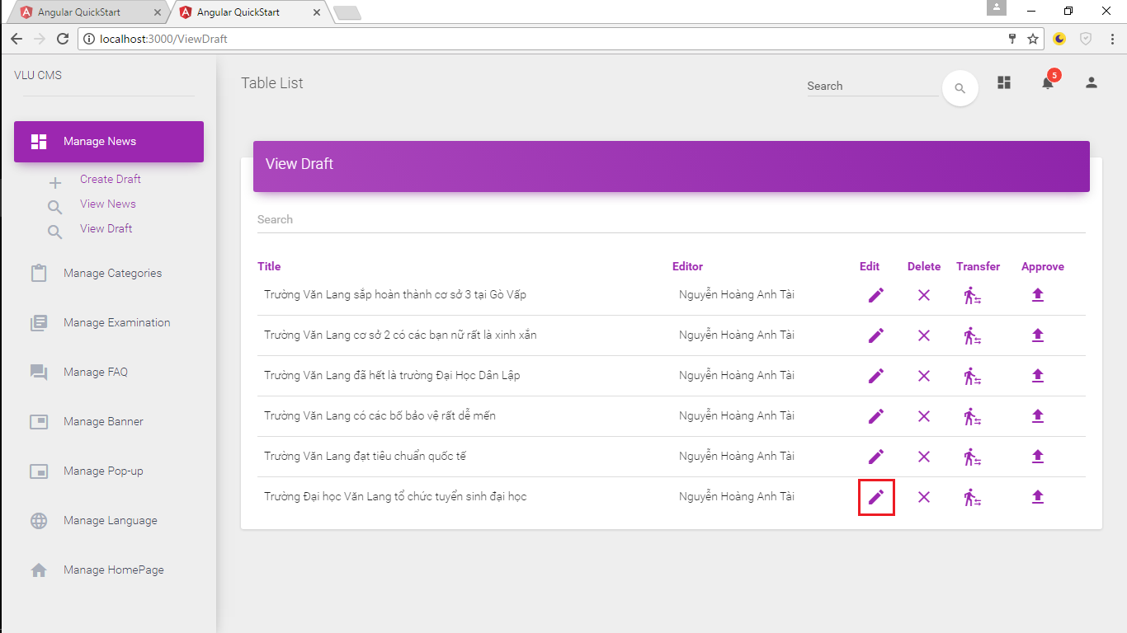

Step 2: Edit information of draft ( Example )

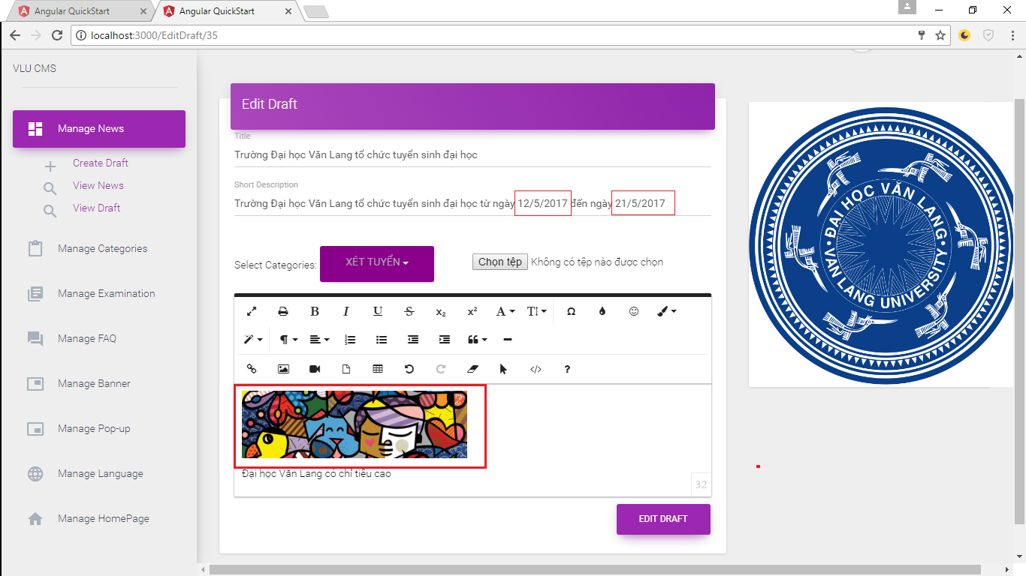

Step 3: Click button “Edit Draft”

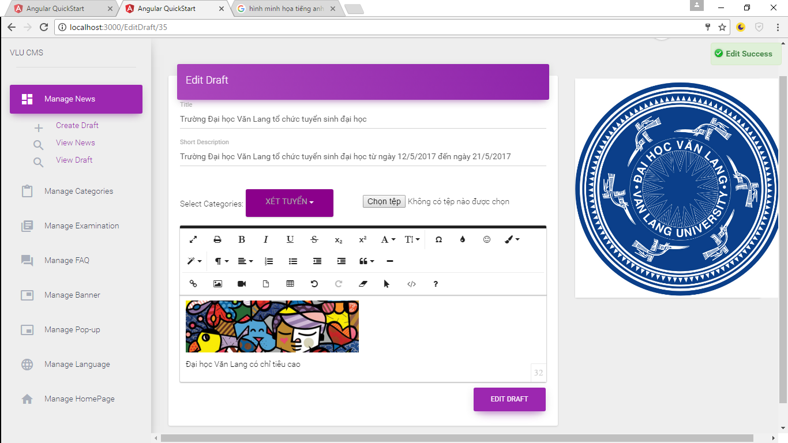

System show message “Edit Success”

* + 1. Delete Draft

Step 1: Click Click View Draft , choose draft & click button “Delete”

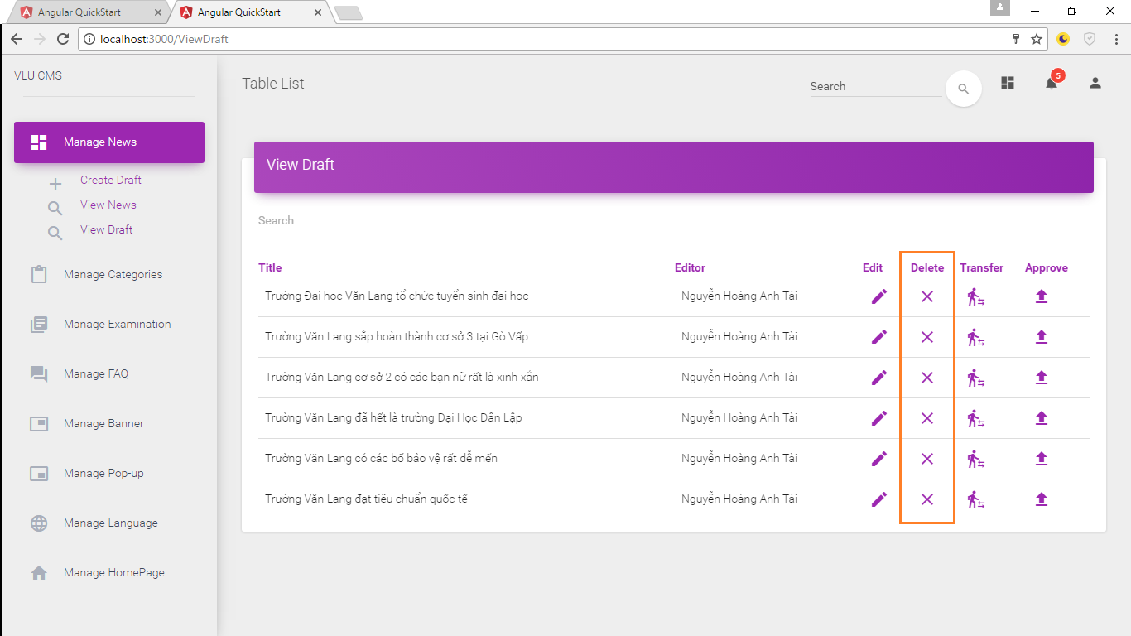

Step 2: System show Notify – Click “YES”

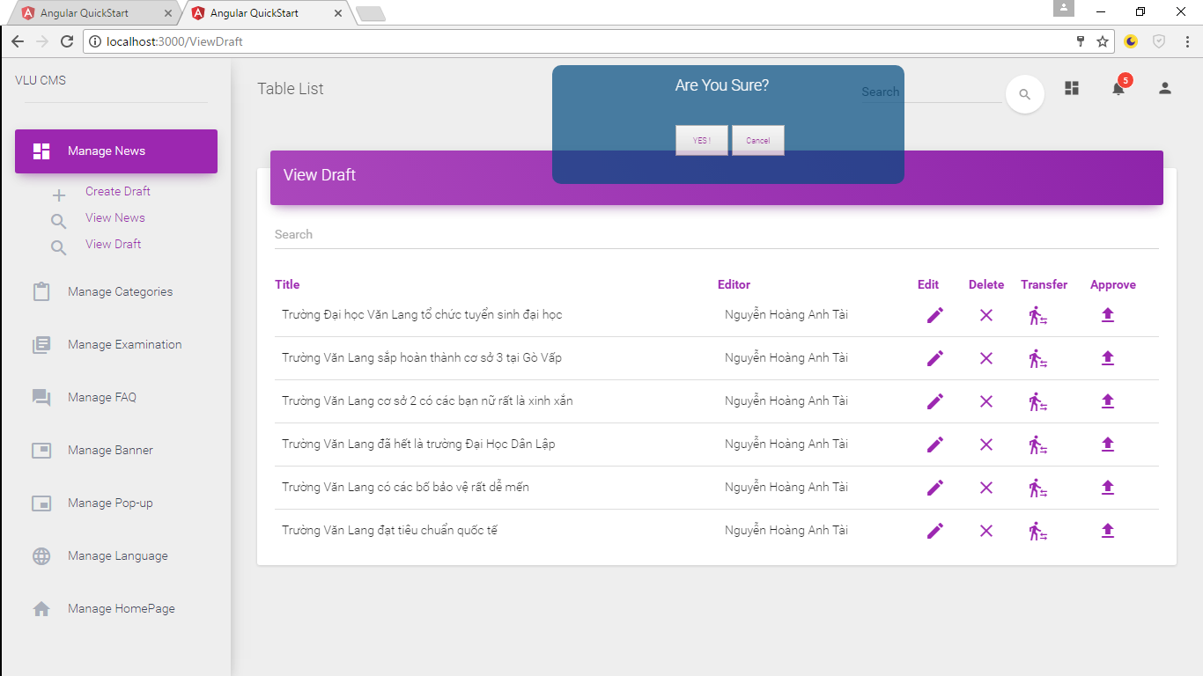

System show message “Delete Success”

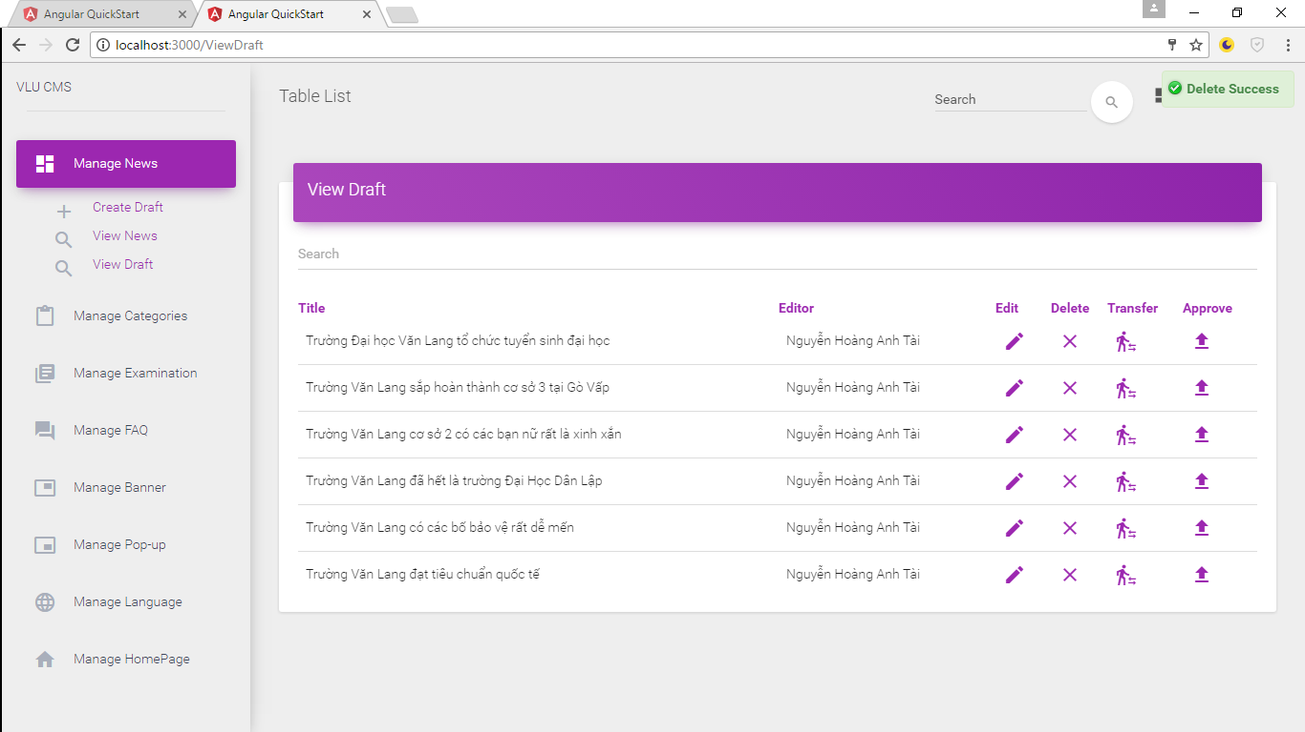

* + 1. Transfer Draft

Step 1: Click View Draft , choose draft & click button “Transfer”

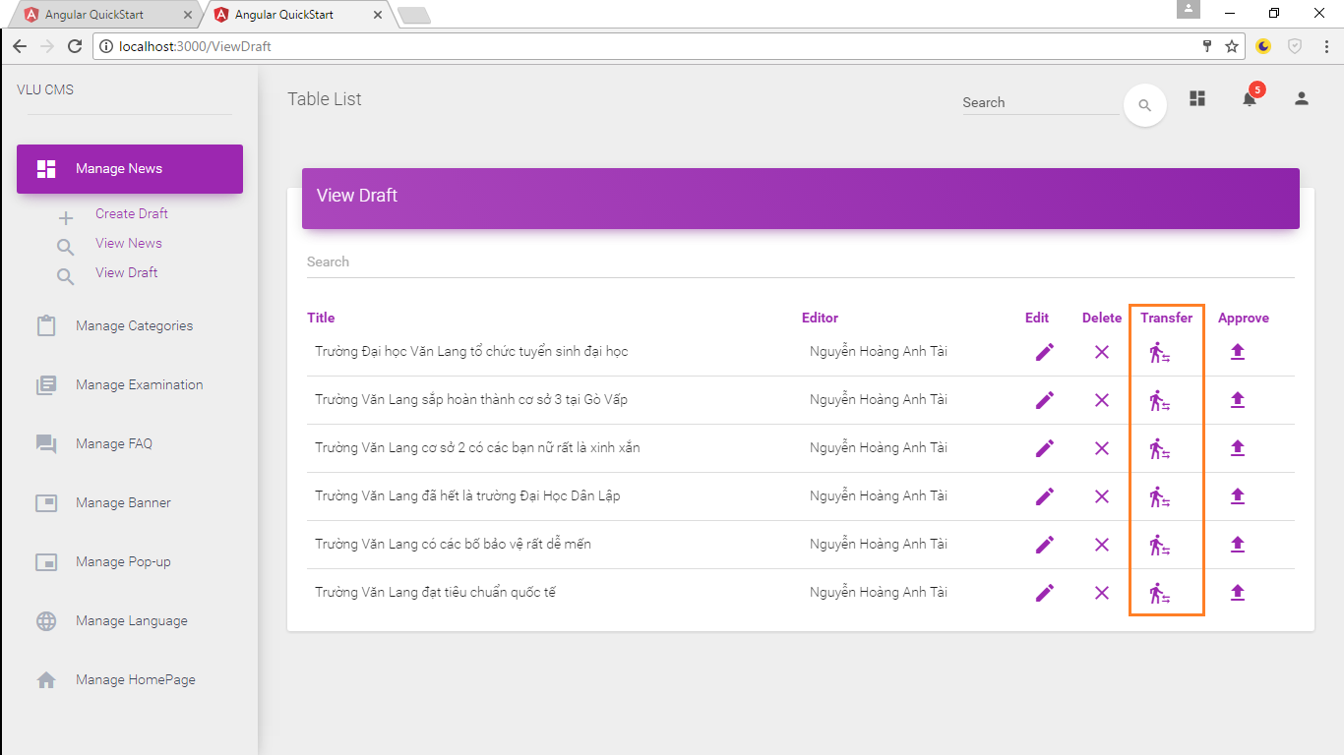

Step 2: Choose person to transfer (Applies only to Content Admin)

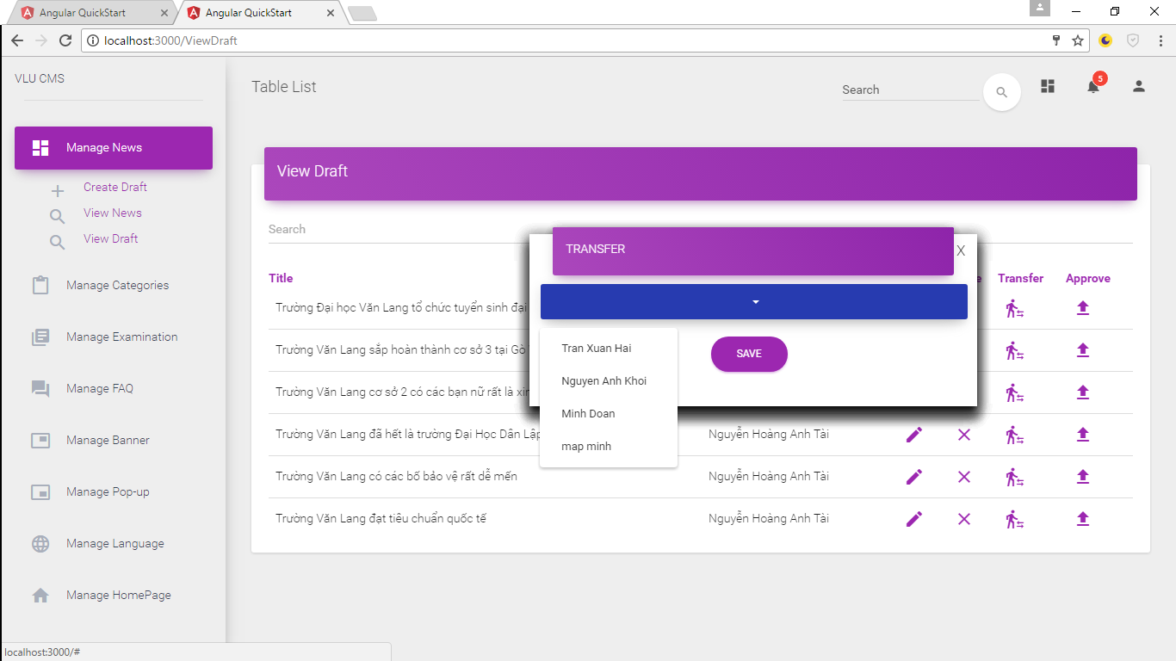

Step 3: Click button “Save” (Applies only to Content Admin)

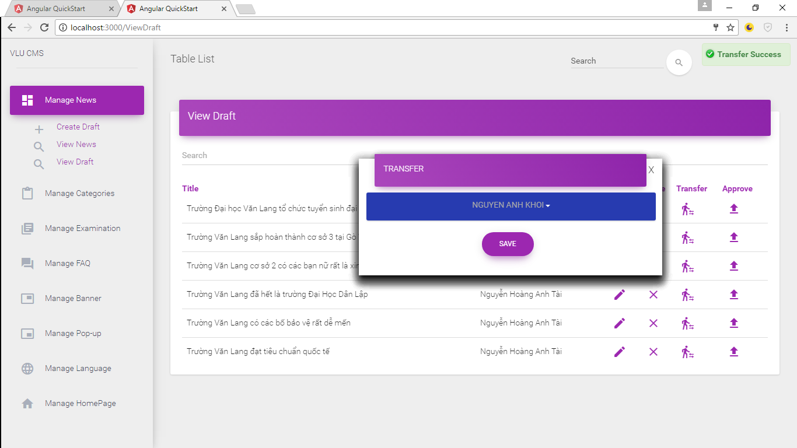

System show message “Transfer Success”

* + 1. Approve Draft

Step 1: Click View Draft , choose draft & click button “Approve”

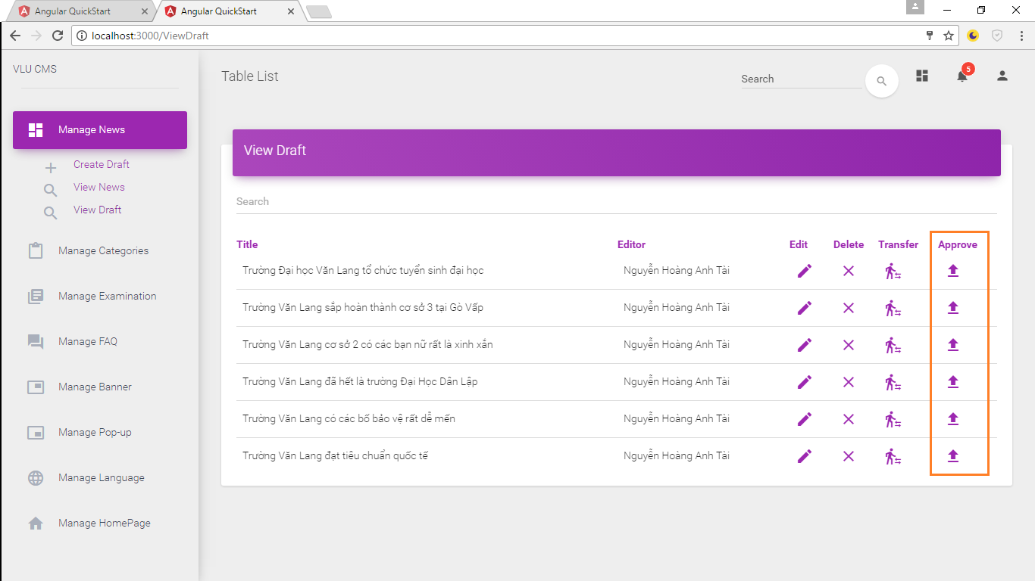

System show message “Approve Success”

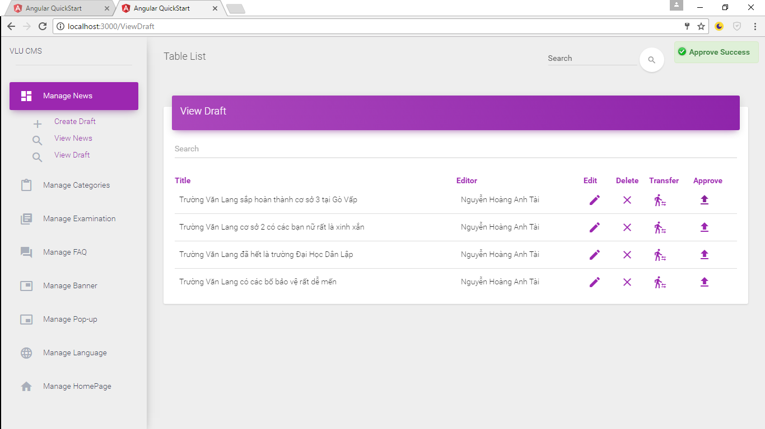

* + 1. Post News

Step 1: Click View News



Step 2: Choose news & check “Post/Deactive”

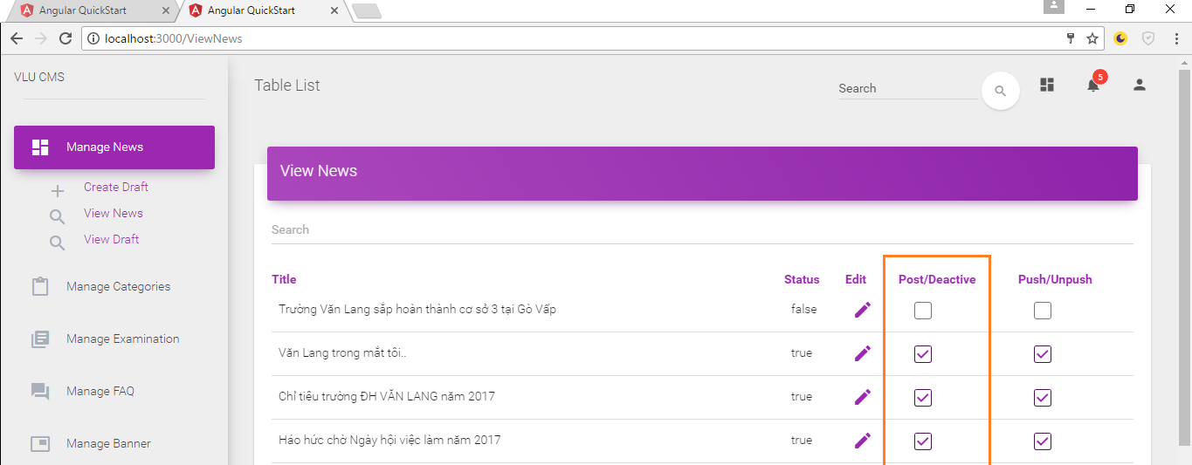

System show message “Post Success”

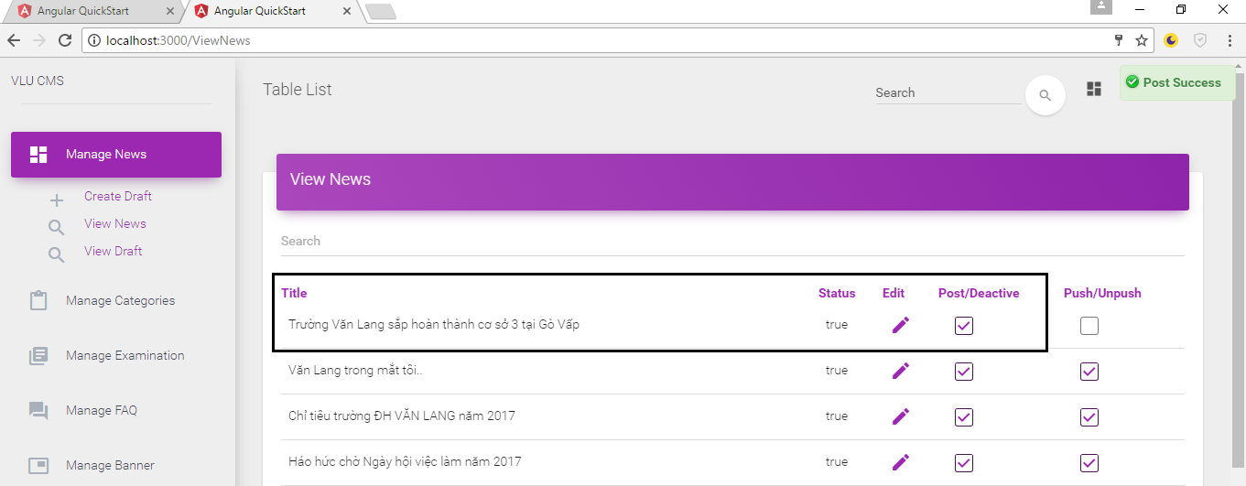

* + 1. Deactive News

Step 1: Click View News

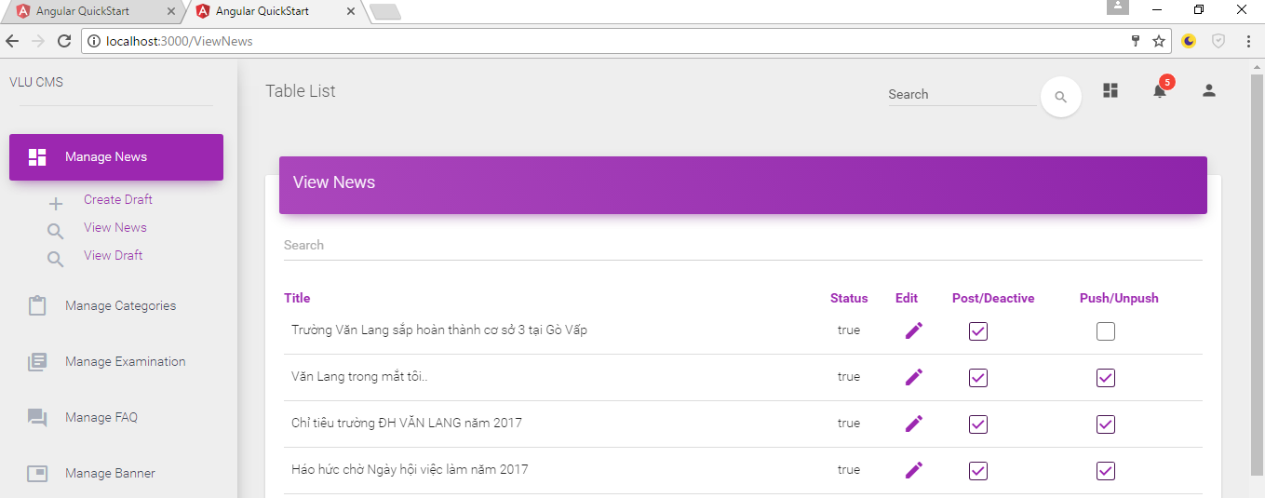

Step 2: Choose news & check “Post/Deactive”

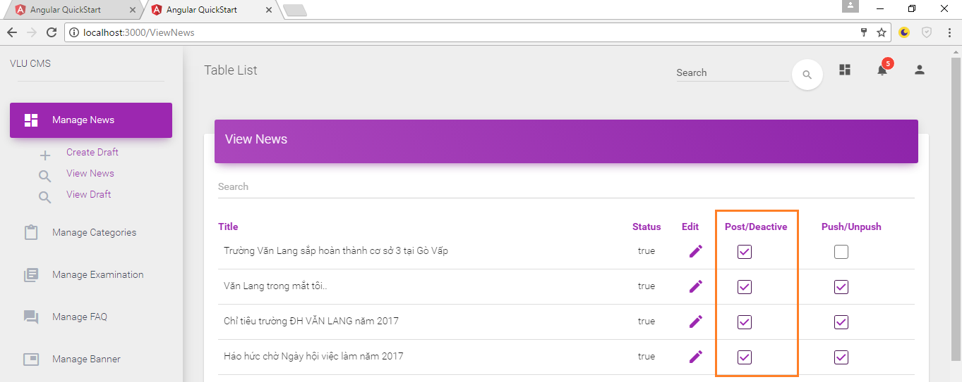

System show message “Deactive Success”

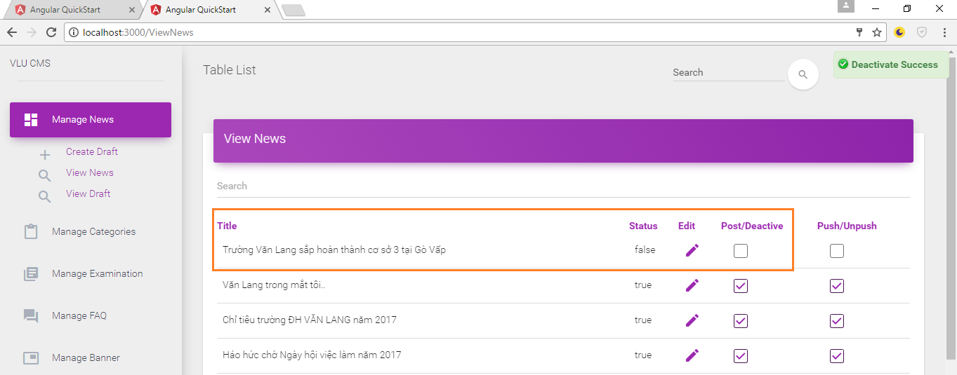

* + 1. Push News

Step 1: Click View News



Step 2: Choose news poshed & check “Push/Unpush”

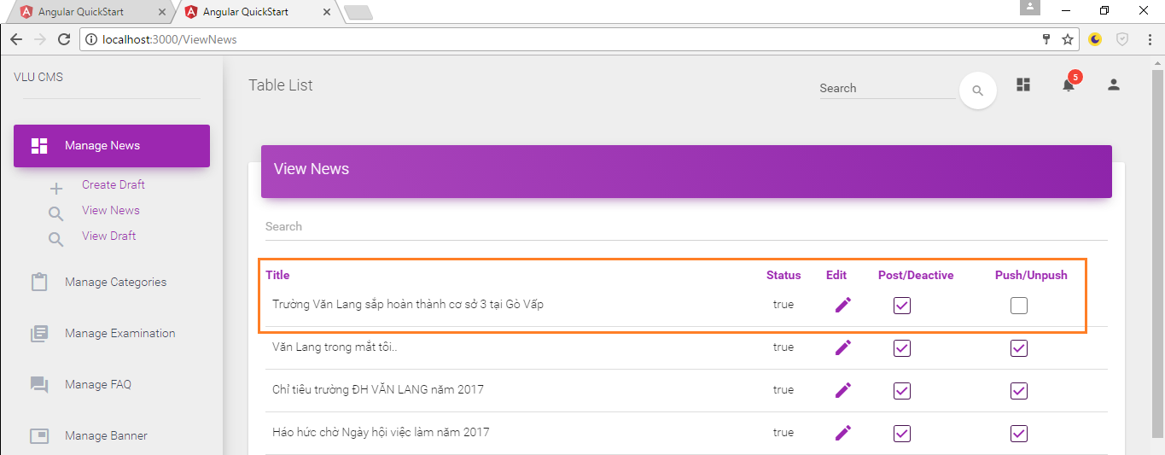

Step 3: System show message “Push Success”

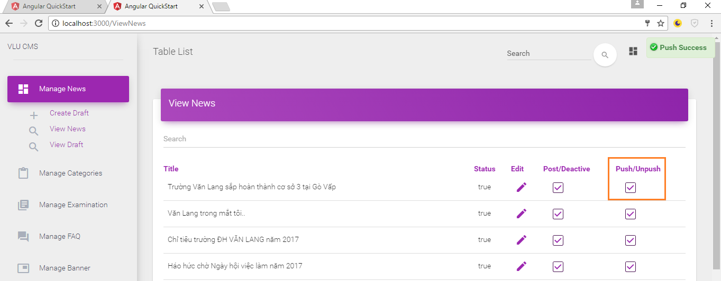

* + 1. Unpush News

Step 1: Click View News



Step 2: Choose news poshed & check “Push/Unpush”

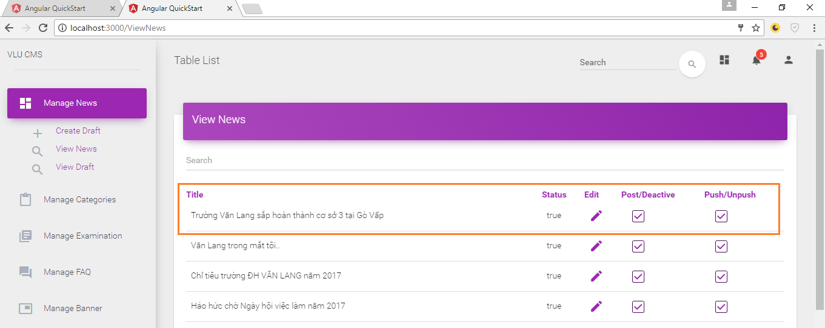

Step 3: System show message “Unpush Success”

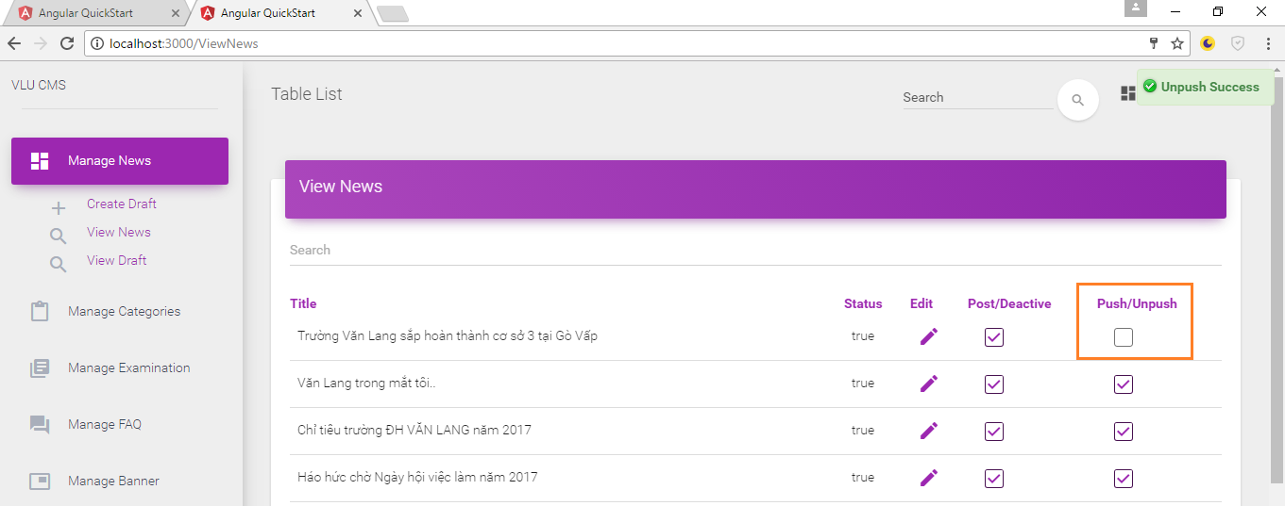

* 1. Manage Category

### 2.3.1 View List of Categories in CMS page

Step 1: Login to CMS page

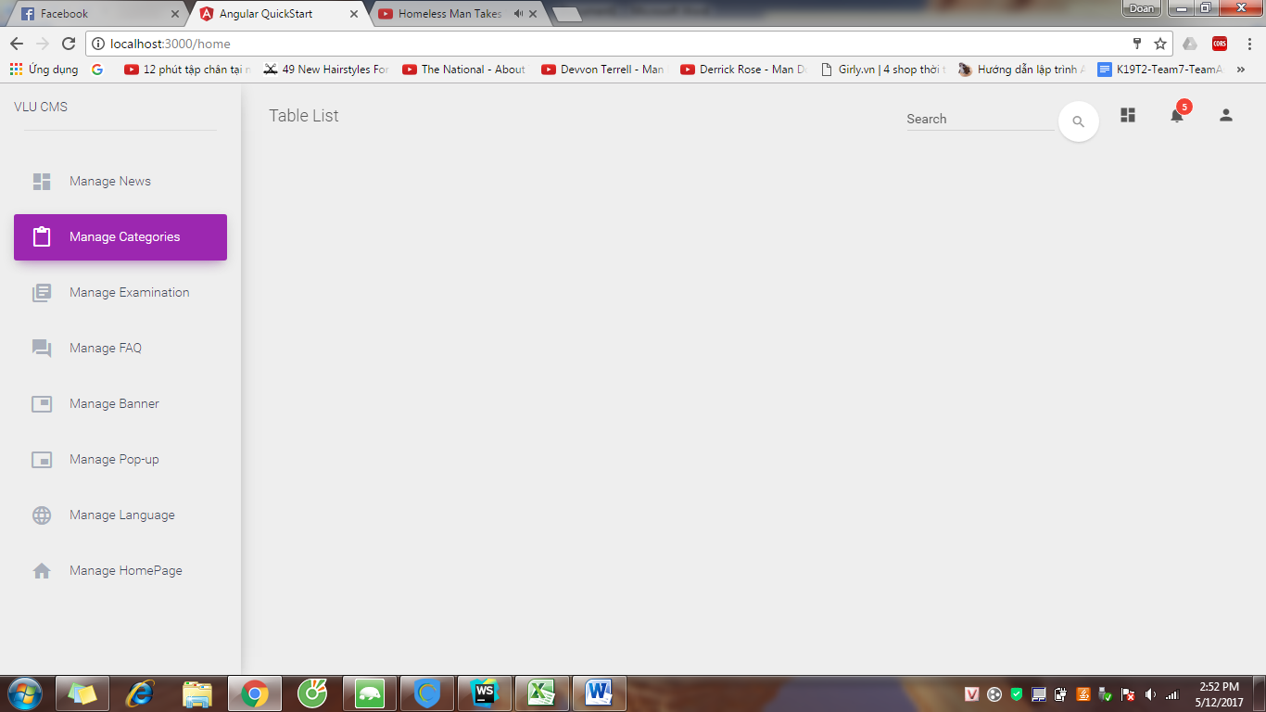

Step 2: Click Manage Categories and click View Categories

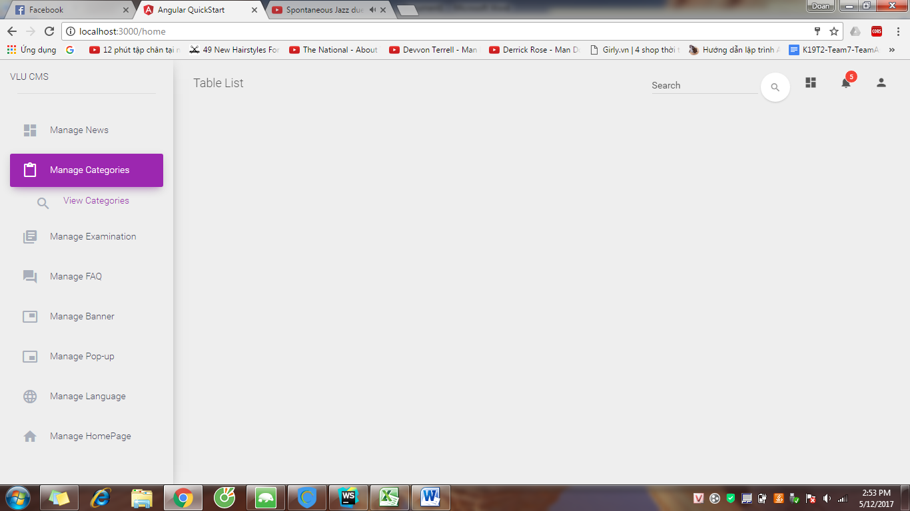

Step 3: System shows View Categories page

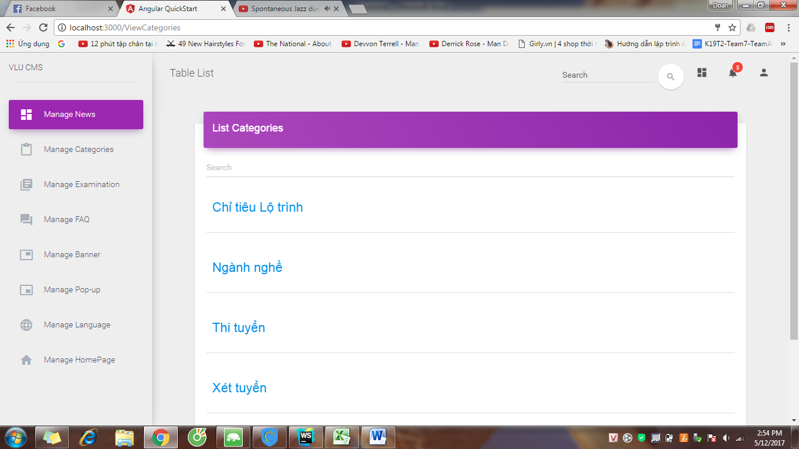

### 2.3.2 Create Category

Step 1: Login to CMS page by Content Admin account

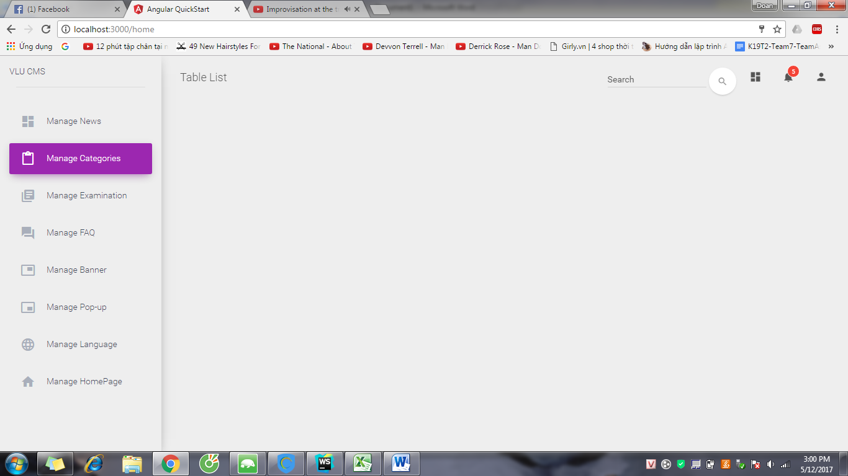

Step 2: Click Manage Categories and click Create Categories

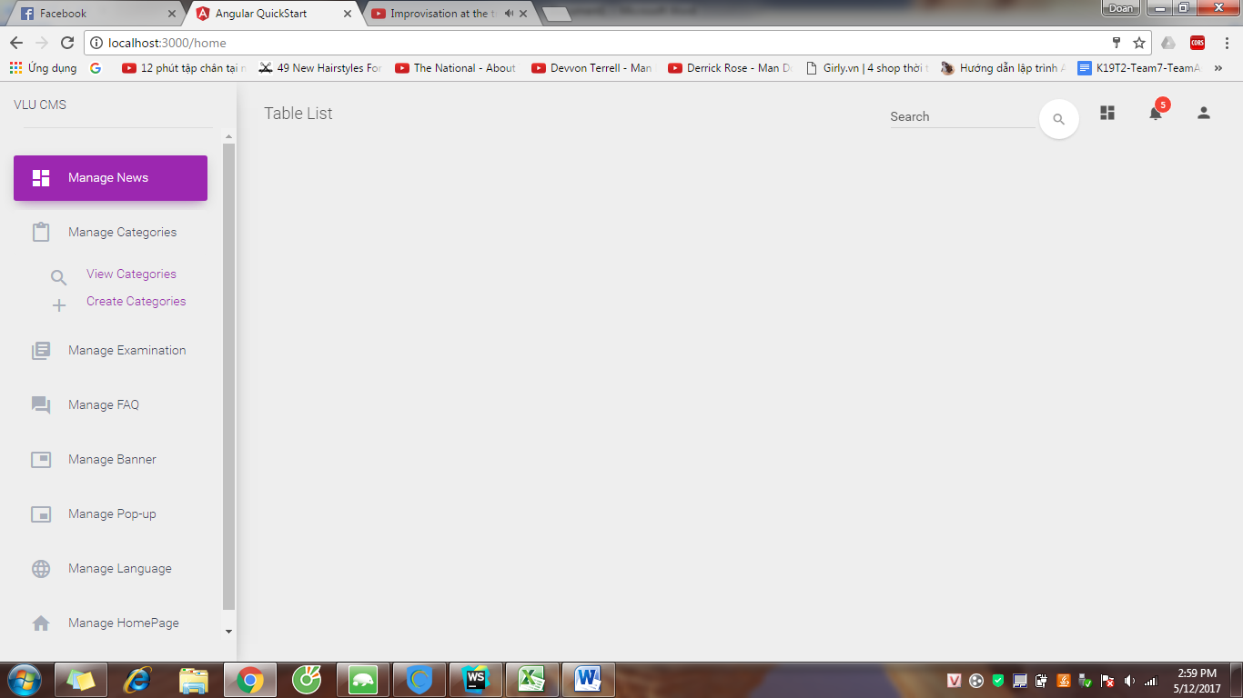

Step 3: System show “Create Categories” page

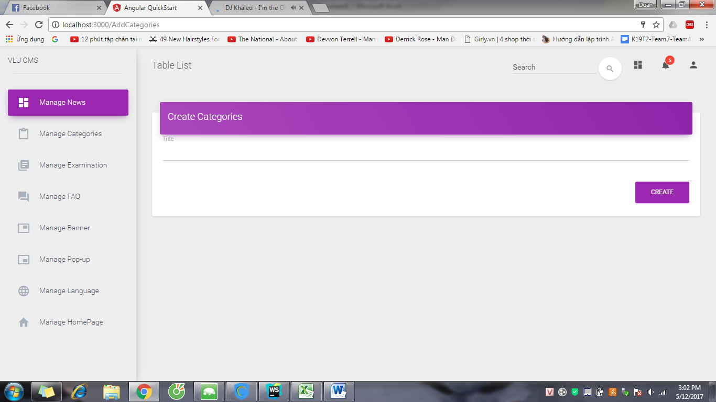

Step 4: Input name of category and click “CREATE” button.

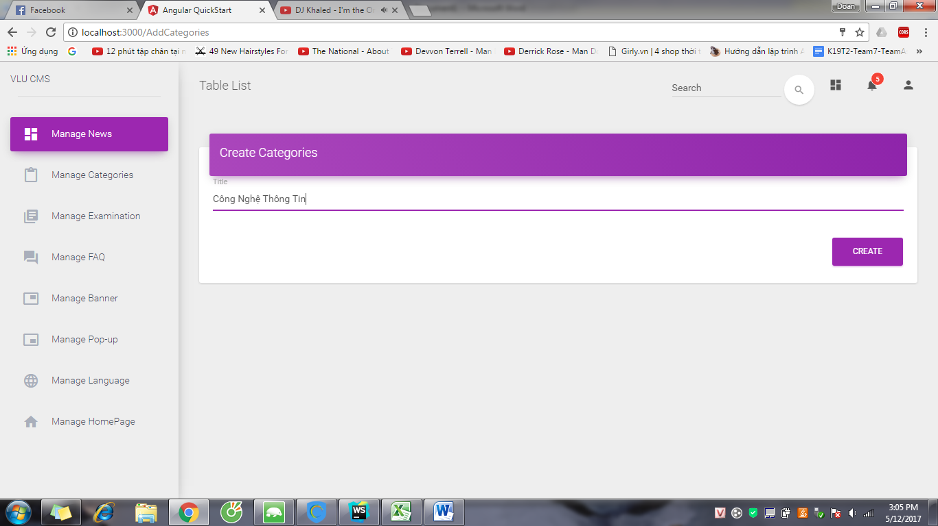

Step 5: System show success message

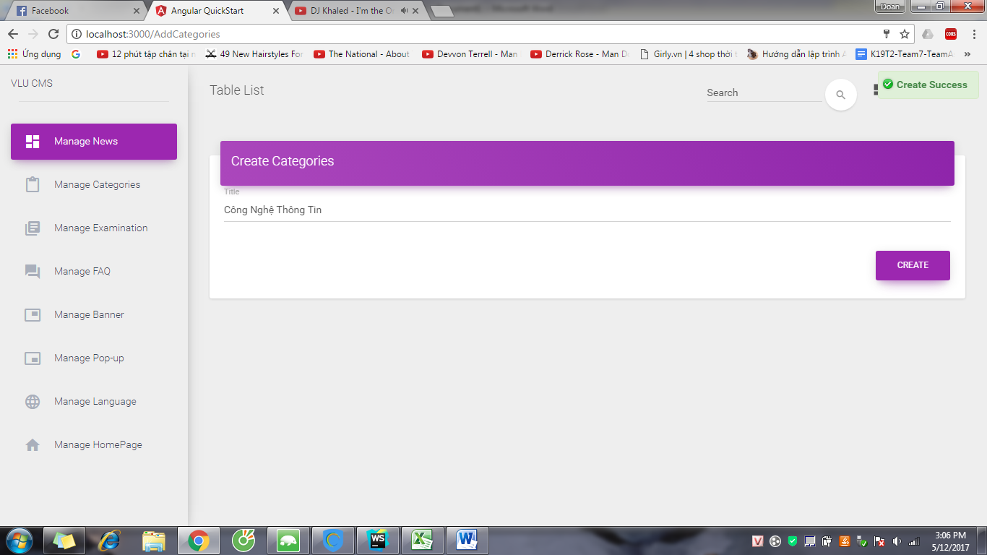

### 2.3.3 Create Categories Level 2

Step 1: Access to View Categories page, choose category and click “”CREATE” button.

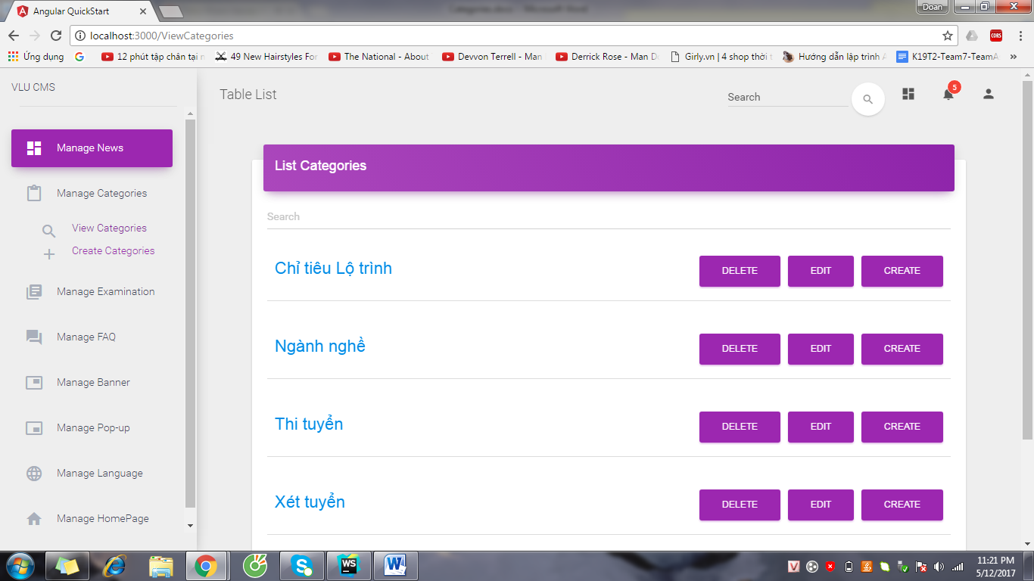

Step 2: System show Create Category Level 2

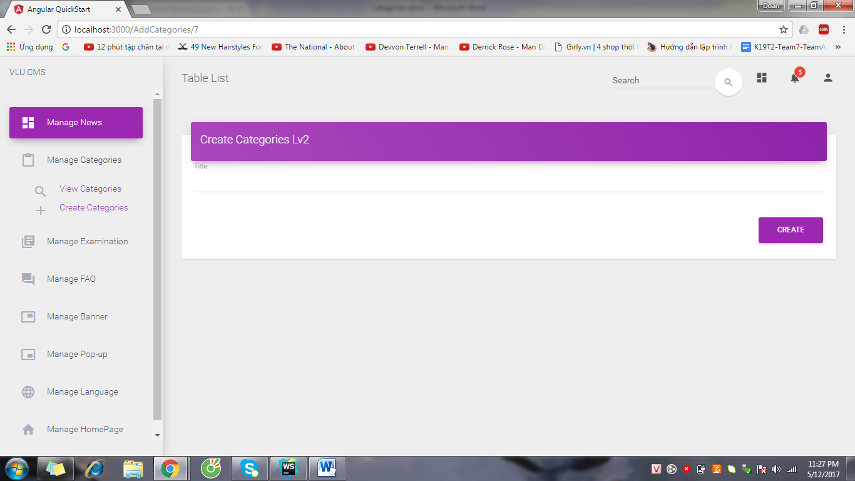

Step 3: Input name of category and click “CREATE” button.

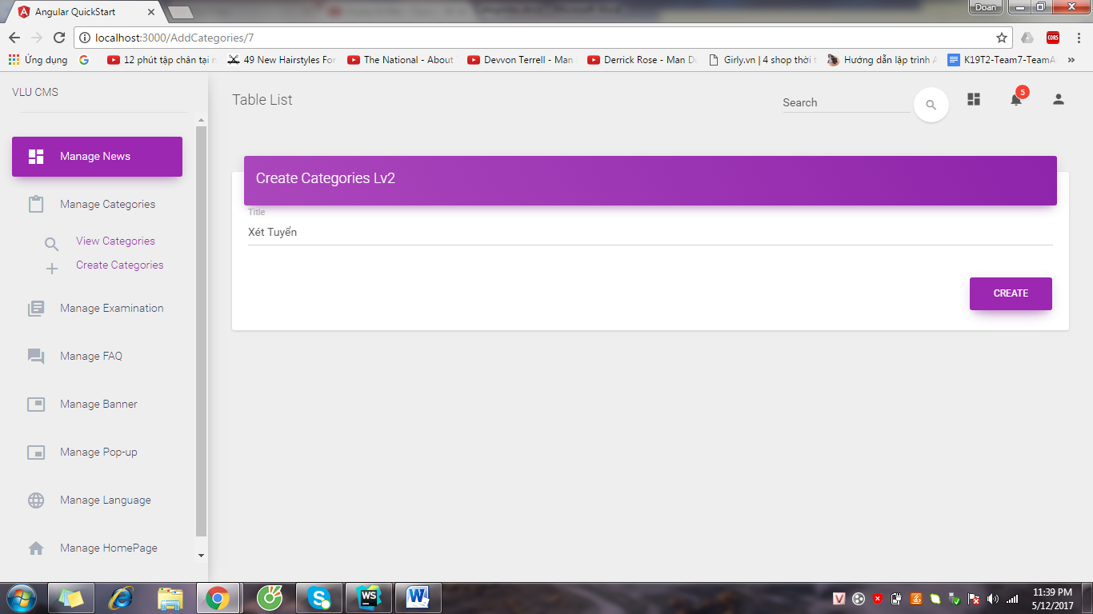

Step 4: System shows success message

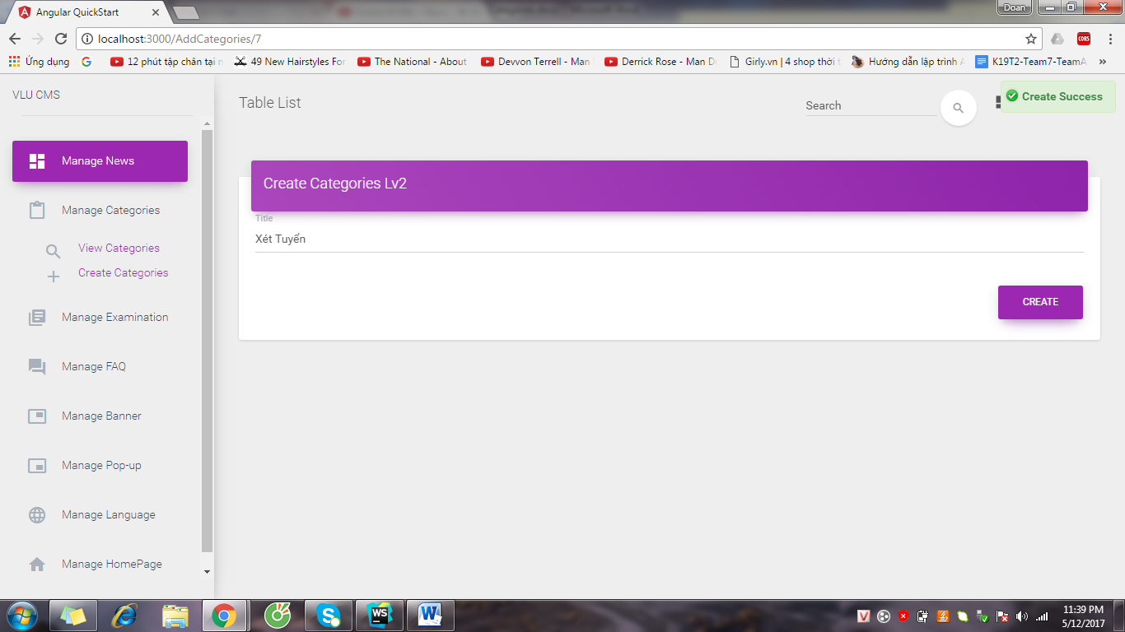

### 2.3.4 Edit Category

Step 1: Access to View Categories page, choose the category and click “EDIT” button

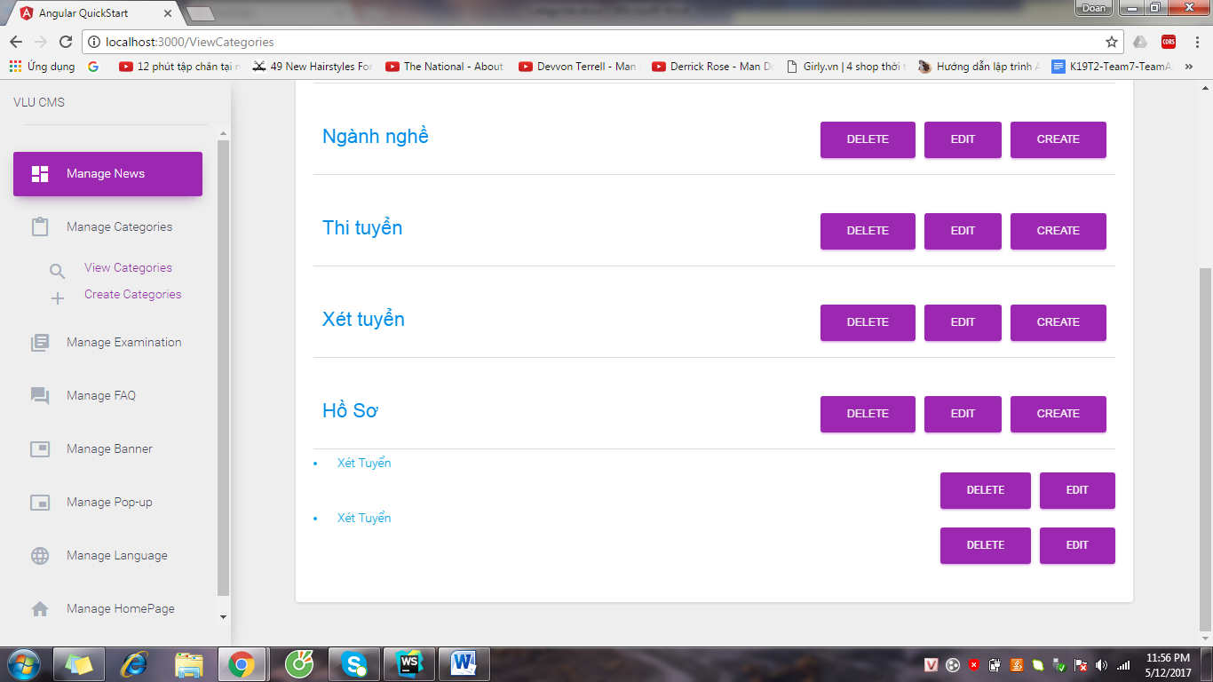

Step 2: System show “Edit Categories” page

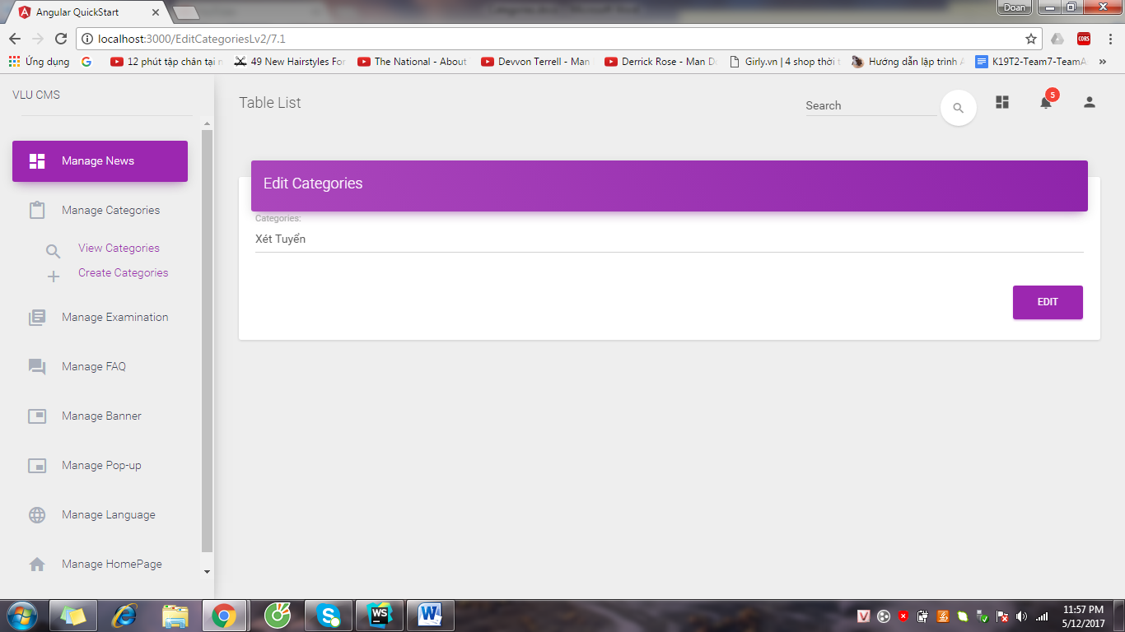

Step 3: Edit name of category and click “EDIT” button

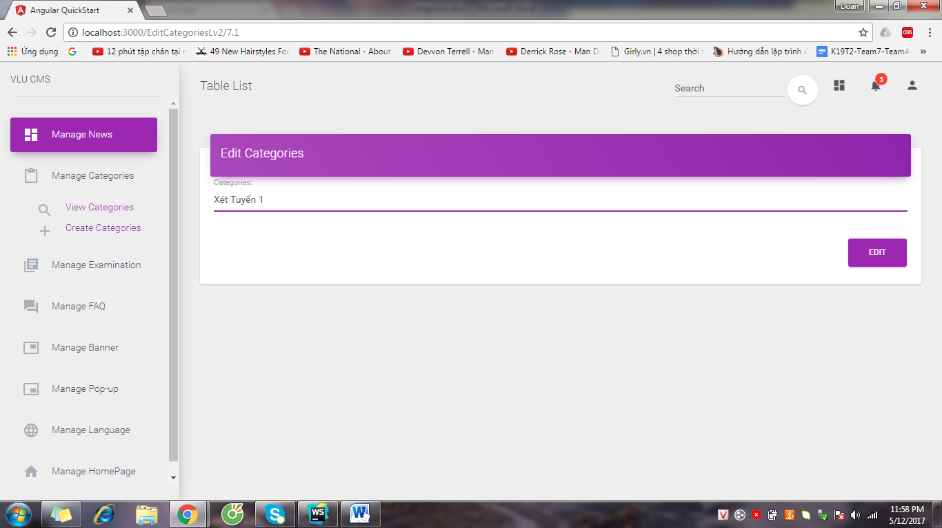

Step 4: System show success message

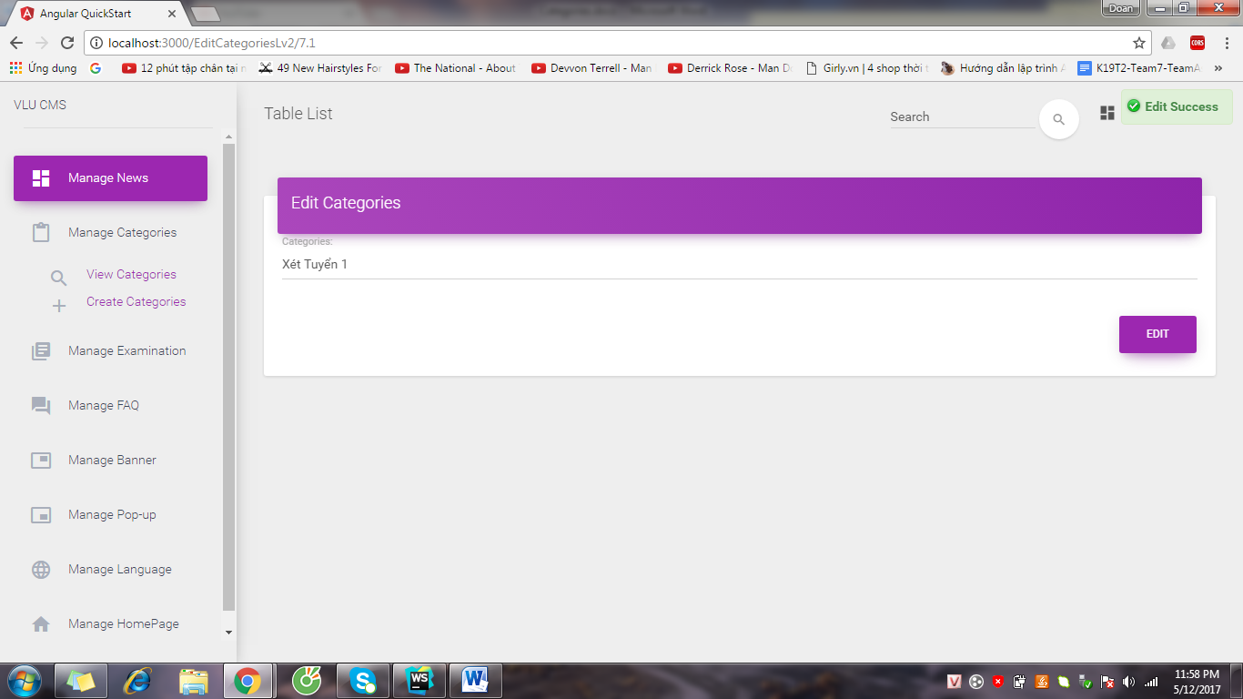

### 2.3.5 Delete Category

Step 1: Access to View Categories page, choose category and click “DELETE” button

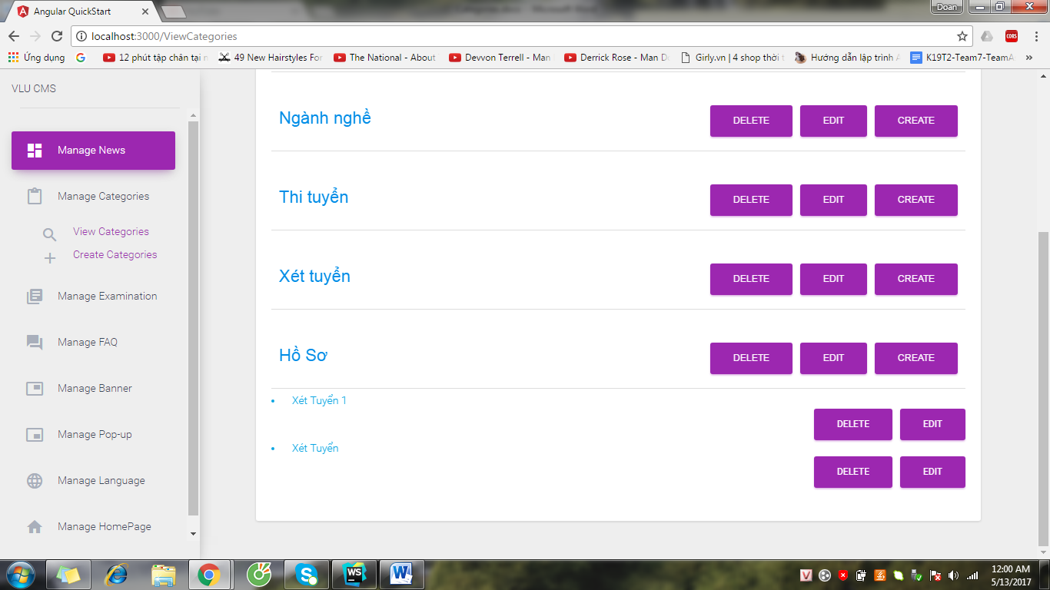

Step 2: System show message

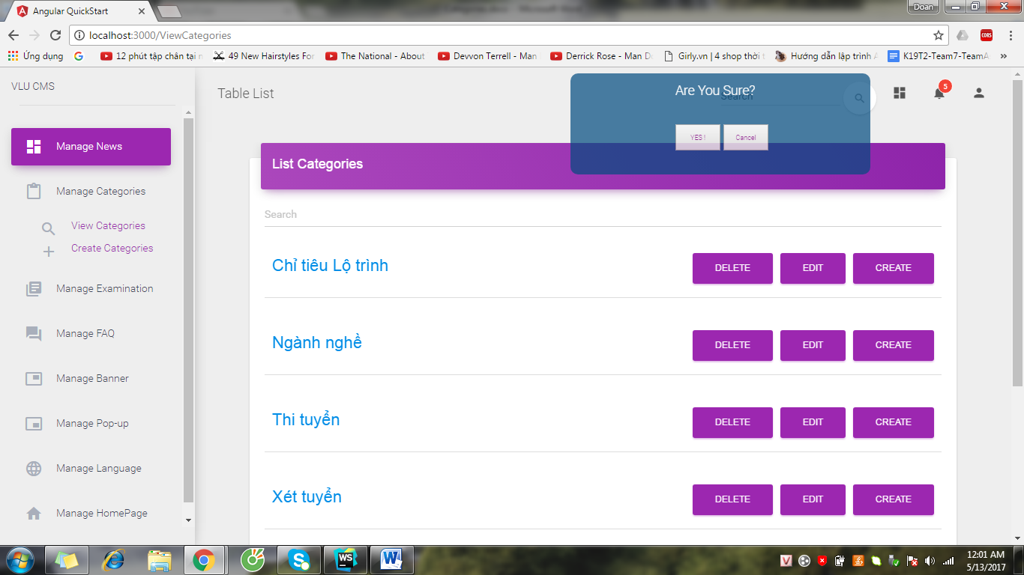

Step 3: Click “YES!” button, System show success message

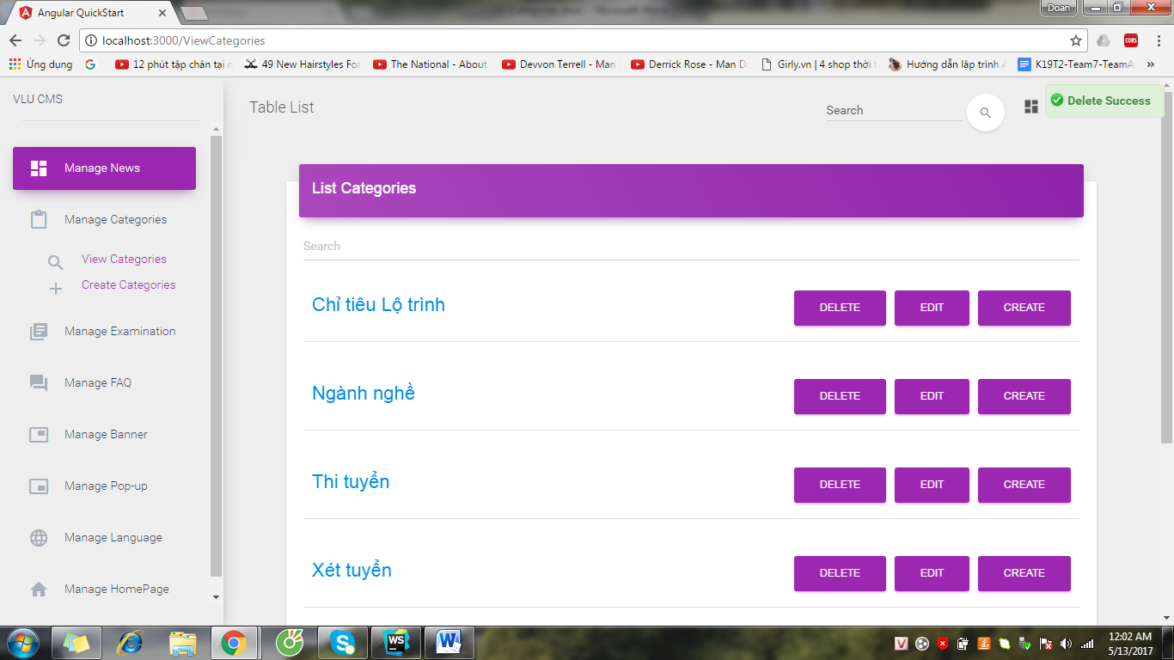

* 1. Manage FAQ

### 2.4.1 View FAQ

Click “Manage FAQ” & click button “No Answer” to see list of unanswered questions

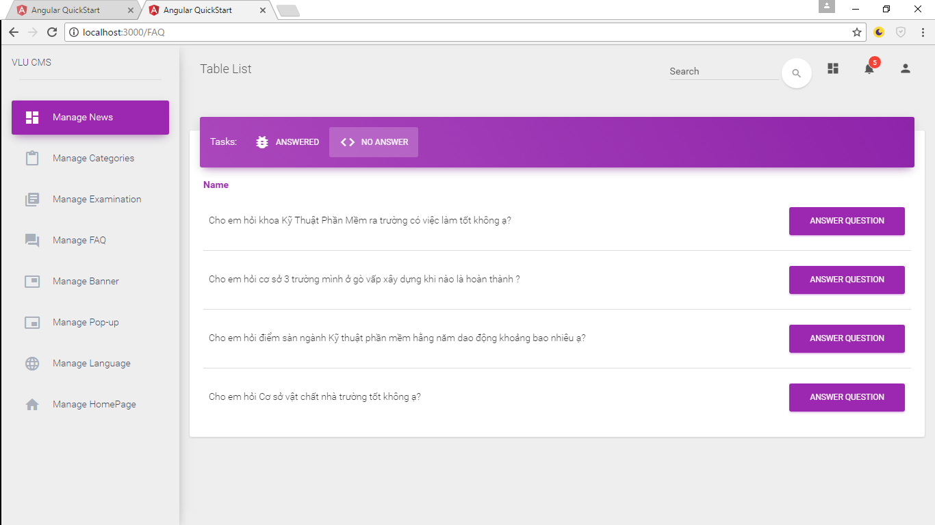

Click “Manage FAQ” & click button “Answered” to see list of answered questions

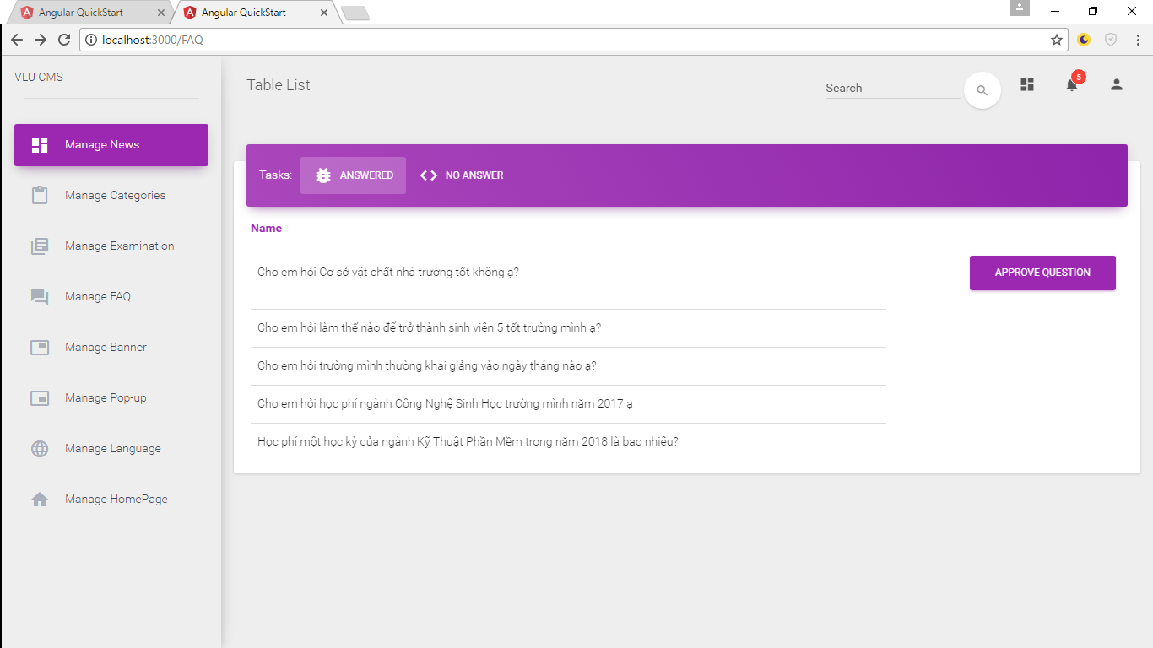

* + 1. Answer Question

Step 1 : Click “Manage FAQ” & click button “No Answer” to see list of unanswered questions



Step 2: Choose question & click button “Answer Question”

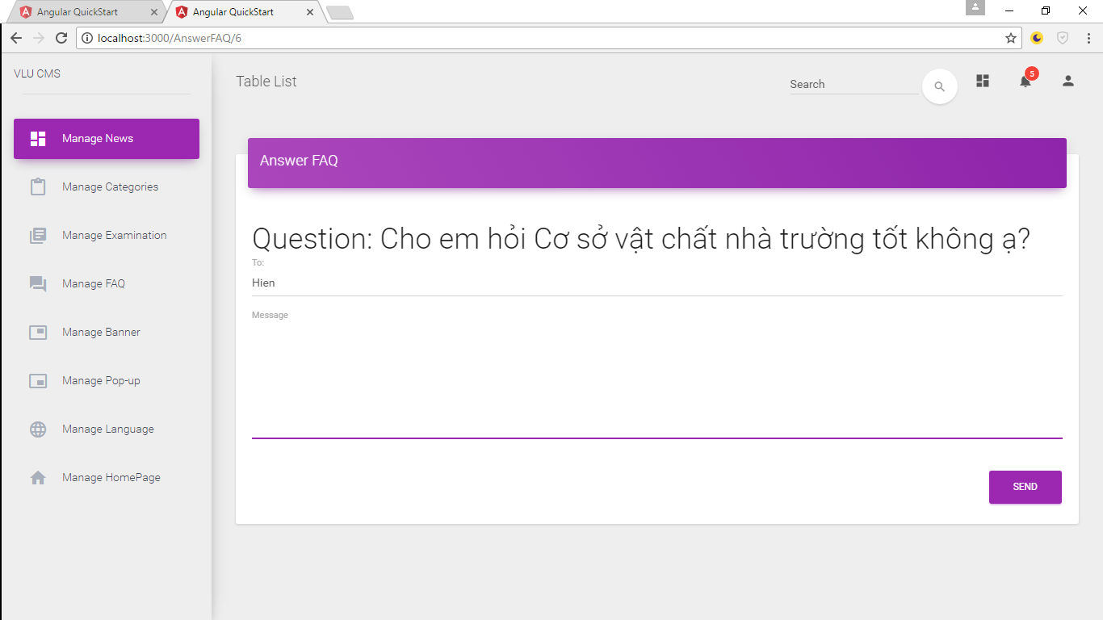

Step 3: Enter the answer & click button “Send”

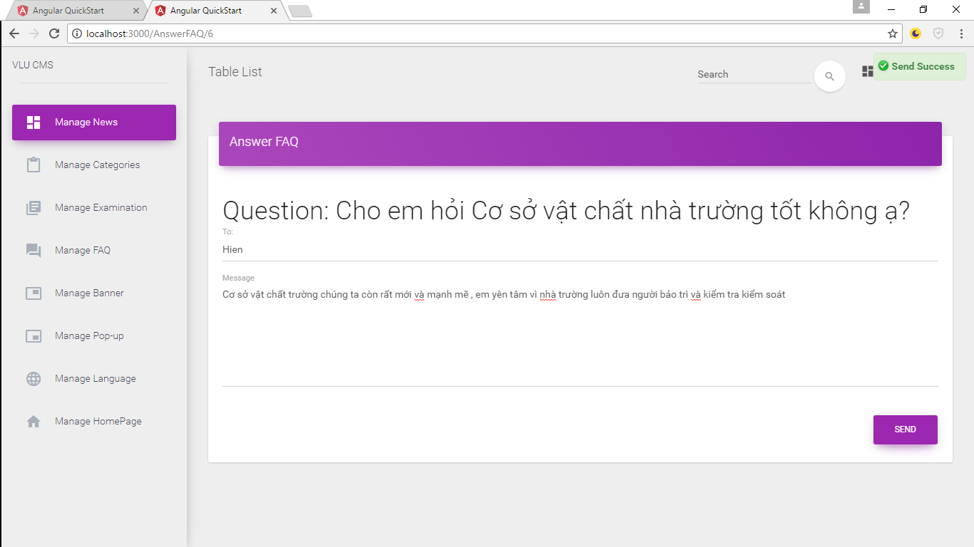

System show message “Send Success”

* + 1. Approve Question

Step 1: Click “Manage FAQ” & click button “Answered” to see list of answered questions



Step 2: Choose question & click button “Approve question”

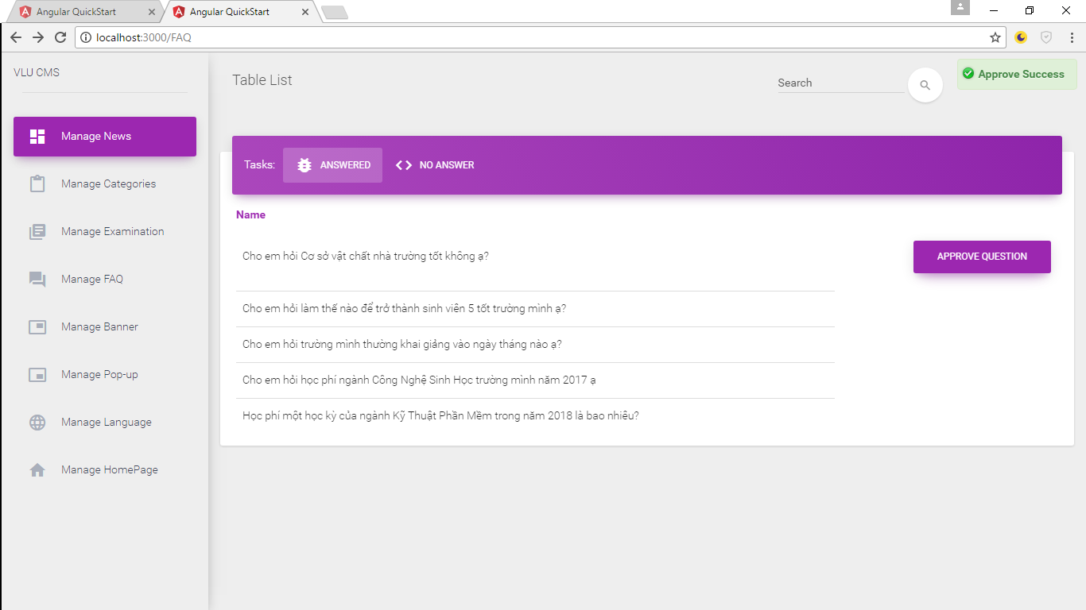

System show message “Approve Success”

* 1. Manage Banner
     1. View Banner in CMS page

Step 1: login to CMS page

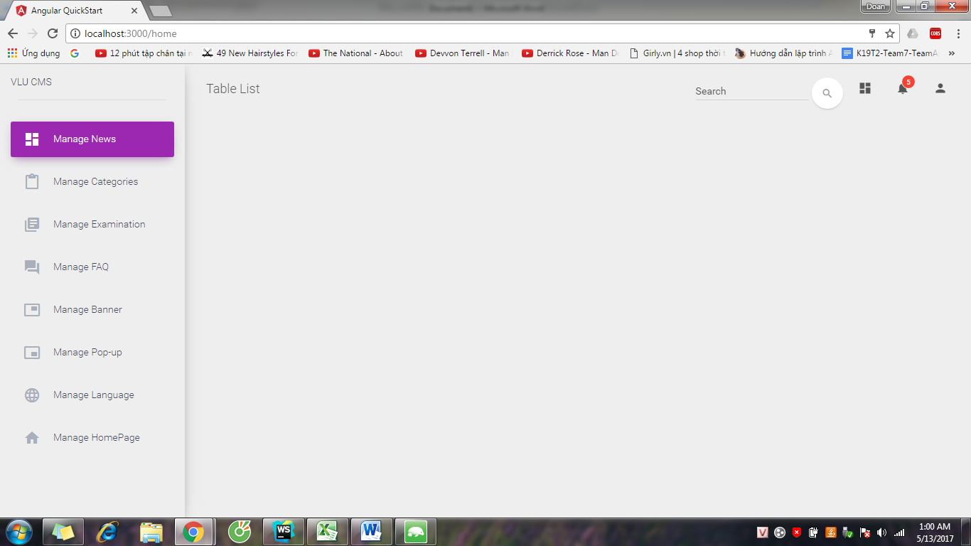

Step 2: Click Manage Banner and click View Banner

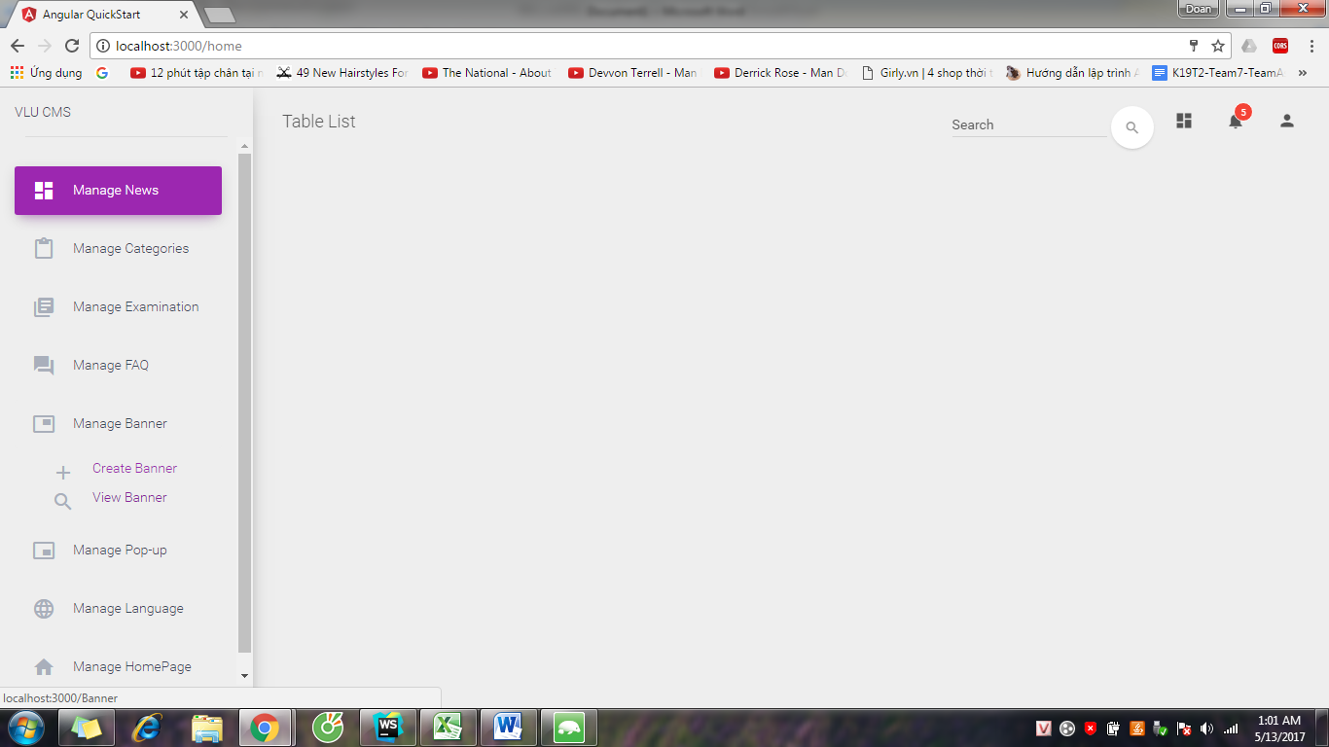

Step 3: System show List Banner page

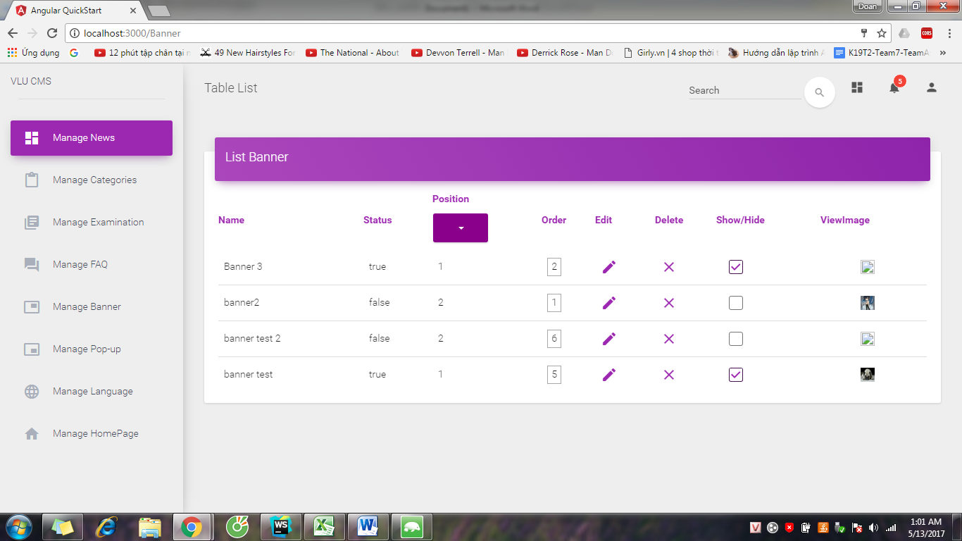

* + 1. Create Banner

Step 1: Login CMS page by Content Admin account



Step 2: Click Manage Banner and click Create Banner



Step 3: System show Create Banner page

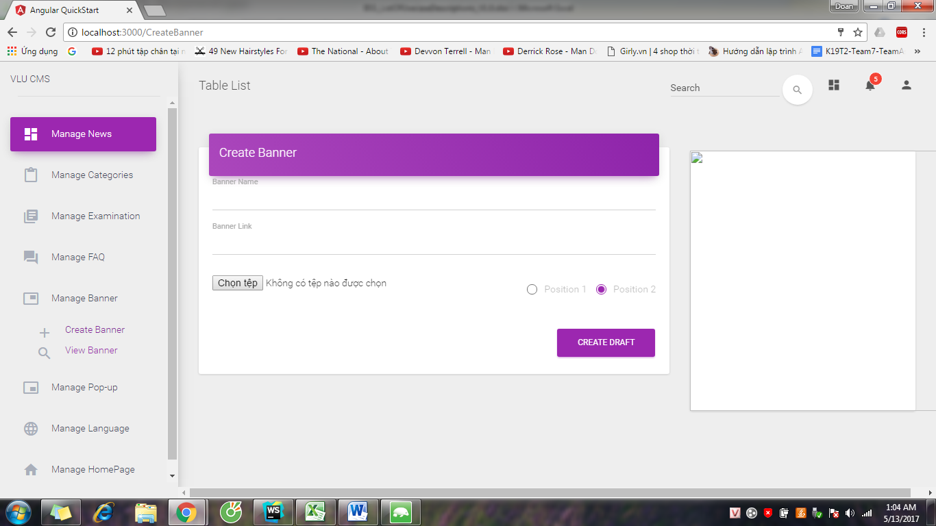

Step 4: Input information of banner, choose position for banner and click “CREATE” button

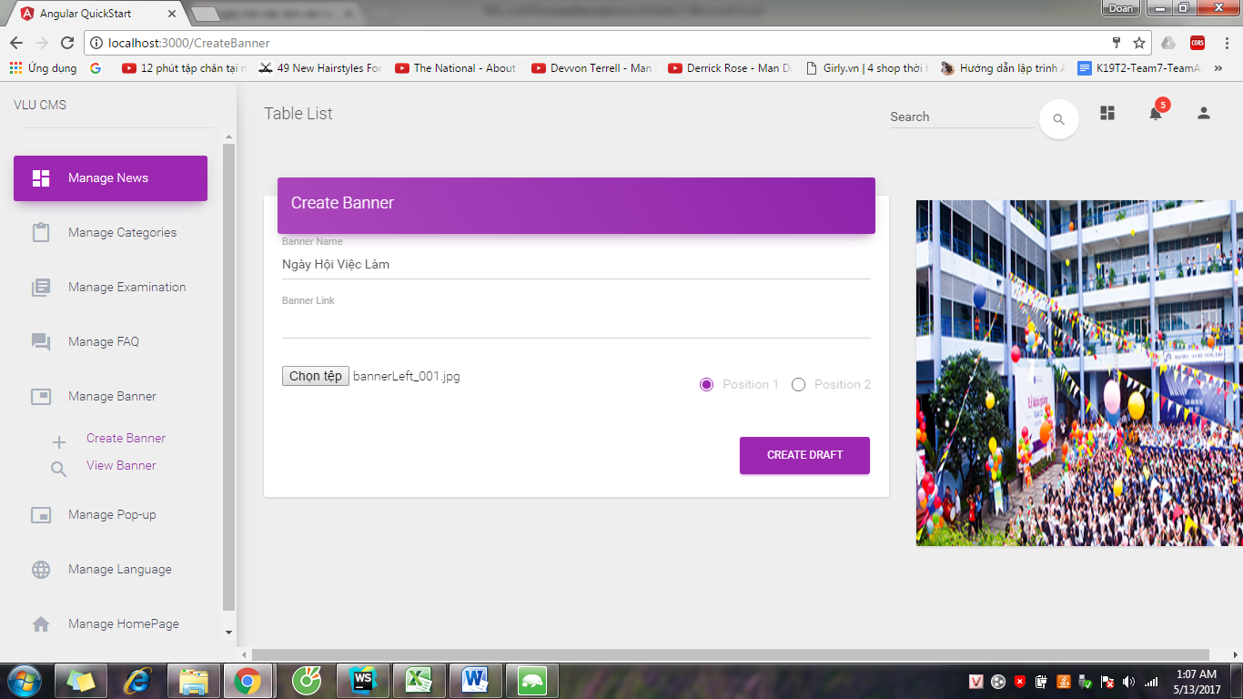

Step 5: System show success message

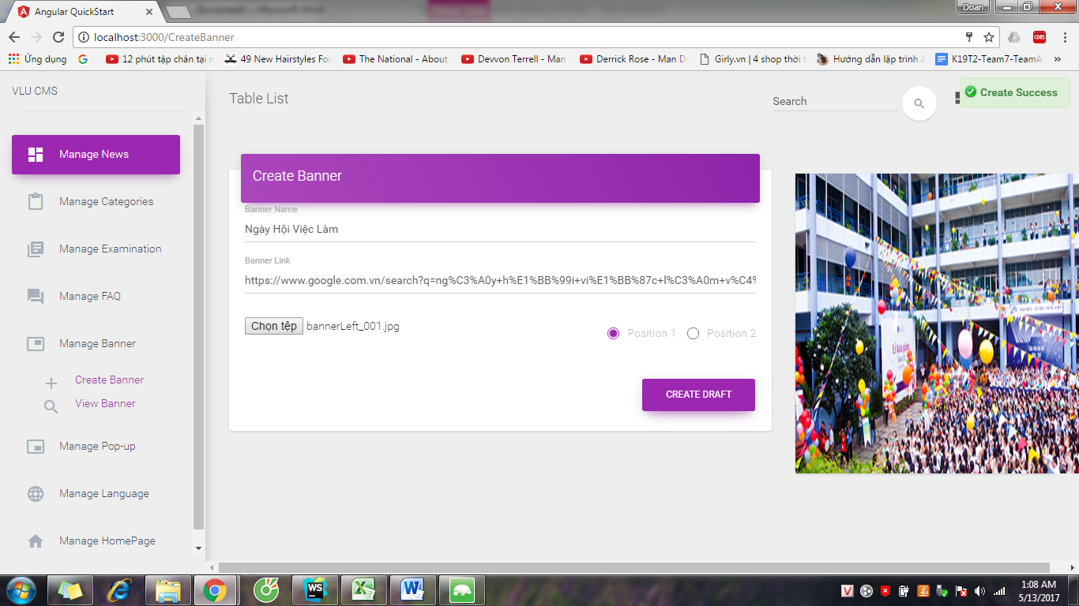

* + 1. Edit Banner

Step 1: Login to CMS page by Content Admin account and access to View Banner page

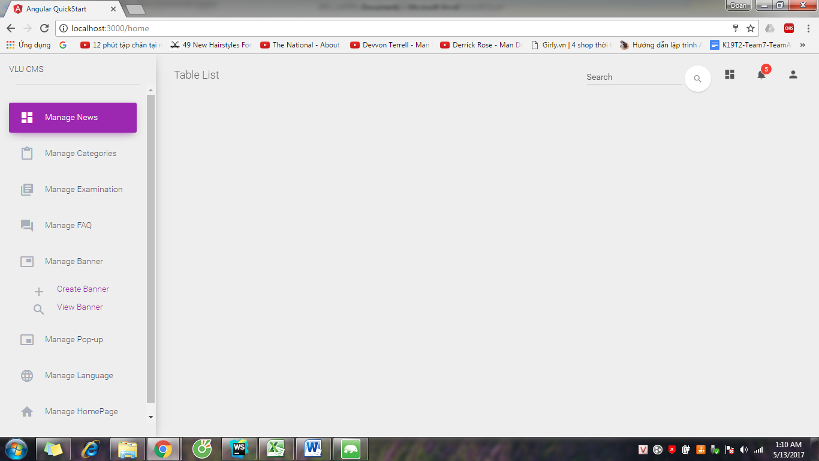

Step 2: System show List Banner page

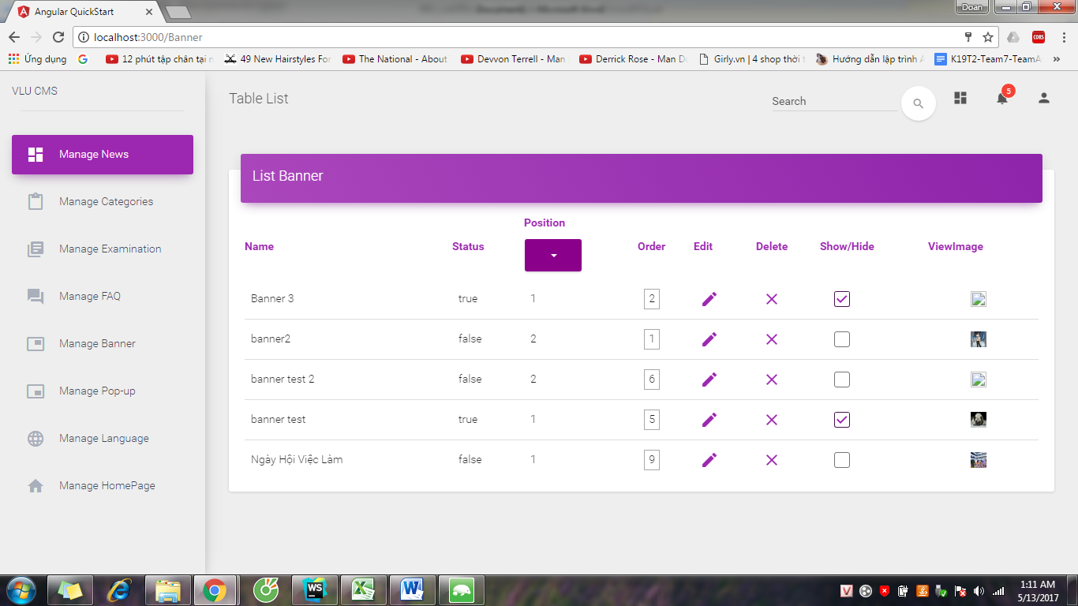

Step 3: Choose banner and click “Edit”. System show “Edit Banner” page

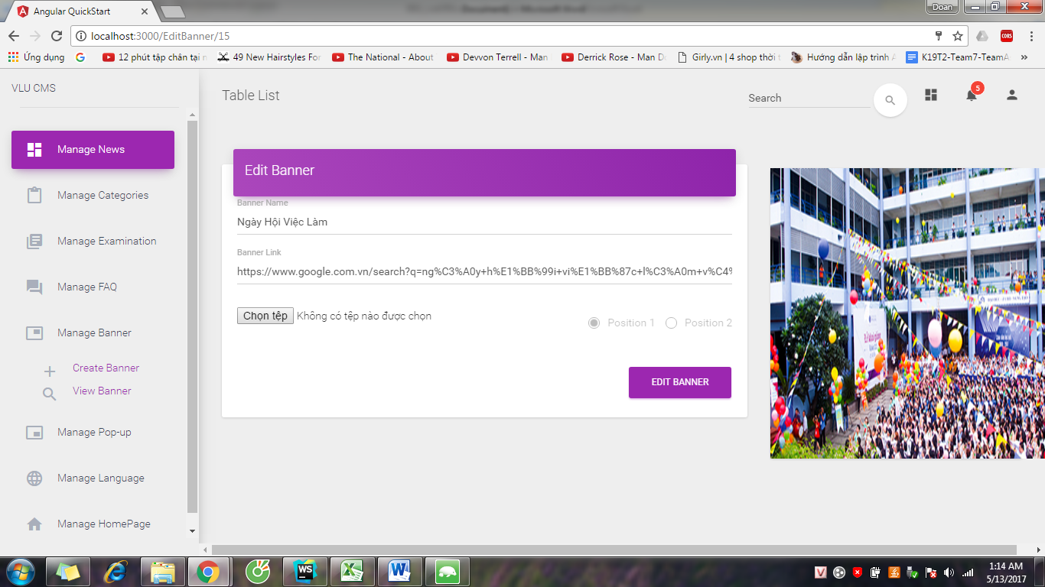

Step 4: Edit information of banner and click “EDIT BANNER” button

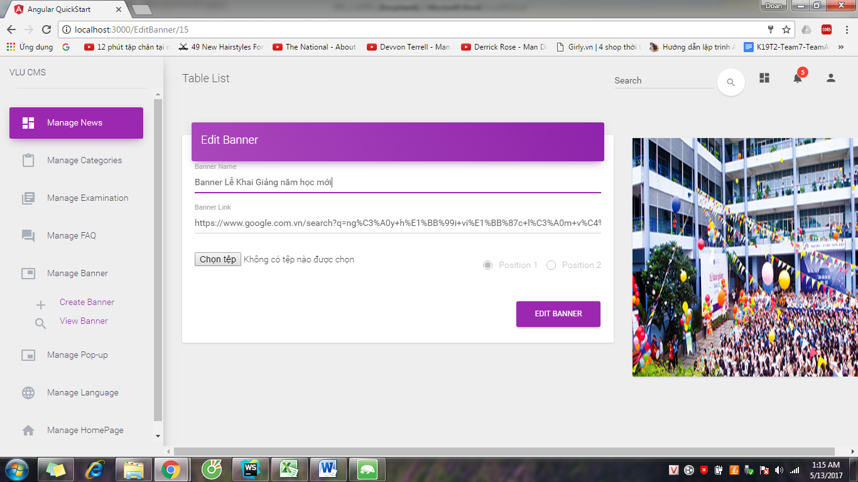

Step 5: System show success message

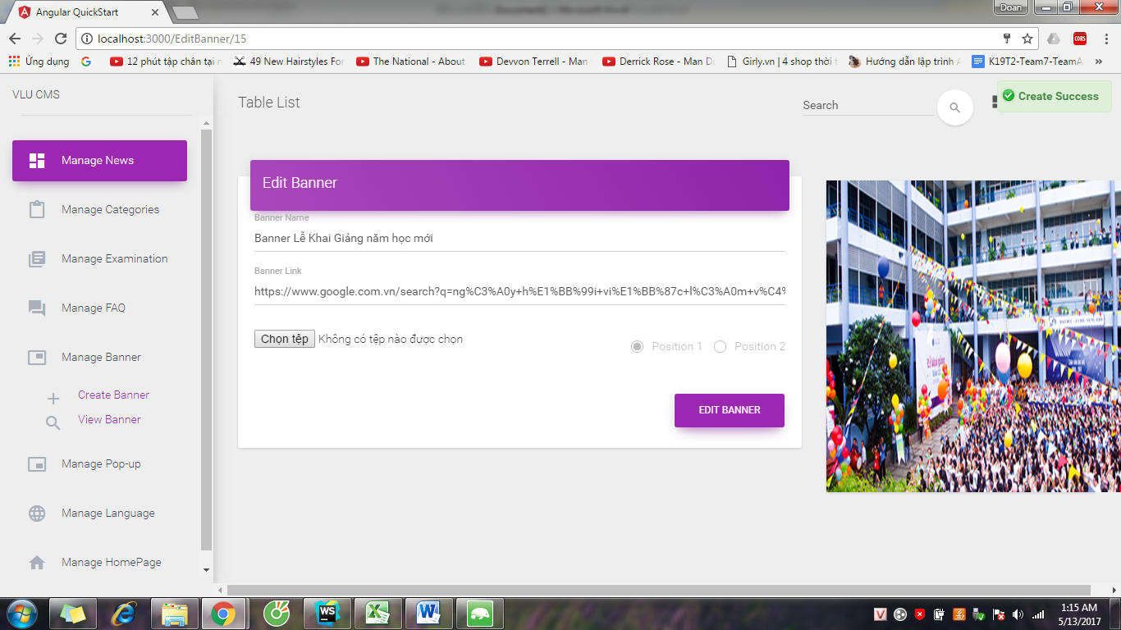

* + 1. Delete Banner

Step 1: Login to CMS page by Content Admin account and access to View Banner page

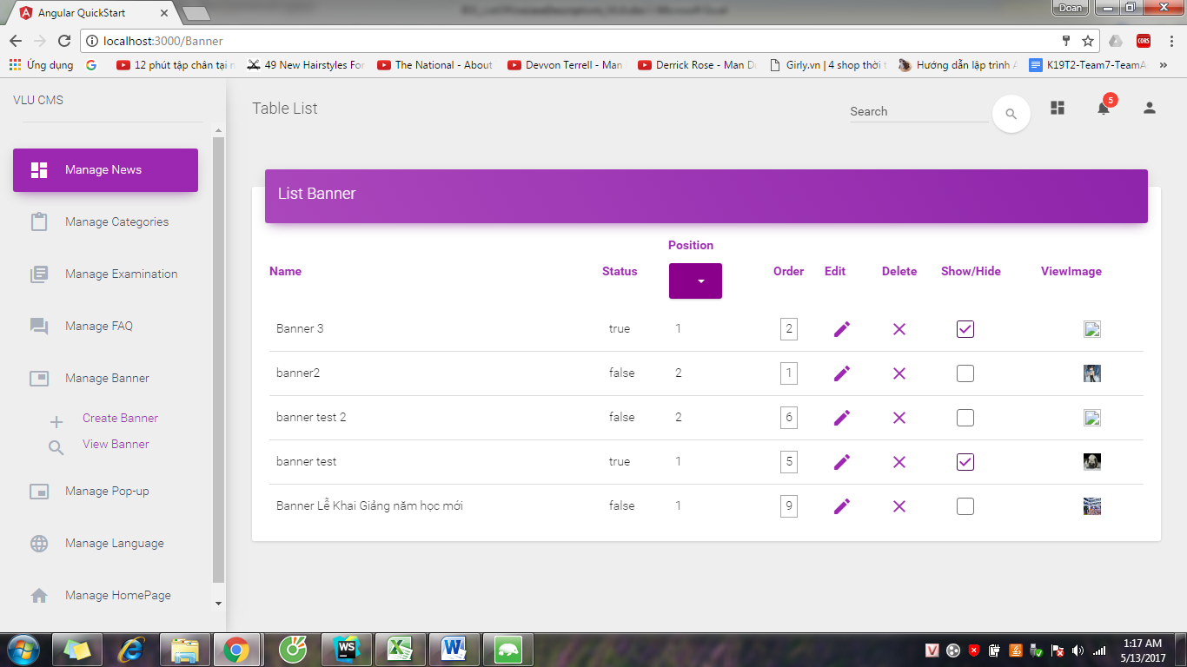

Step 2: Choose banner and click Delete. System show success message

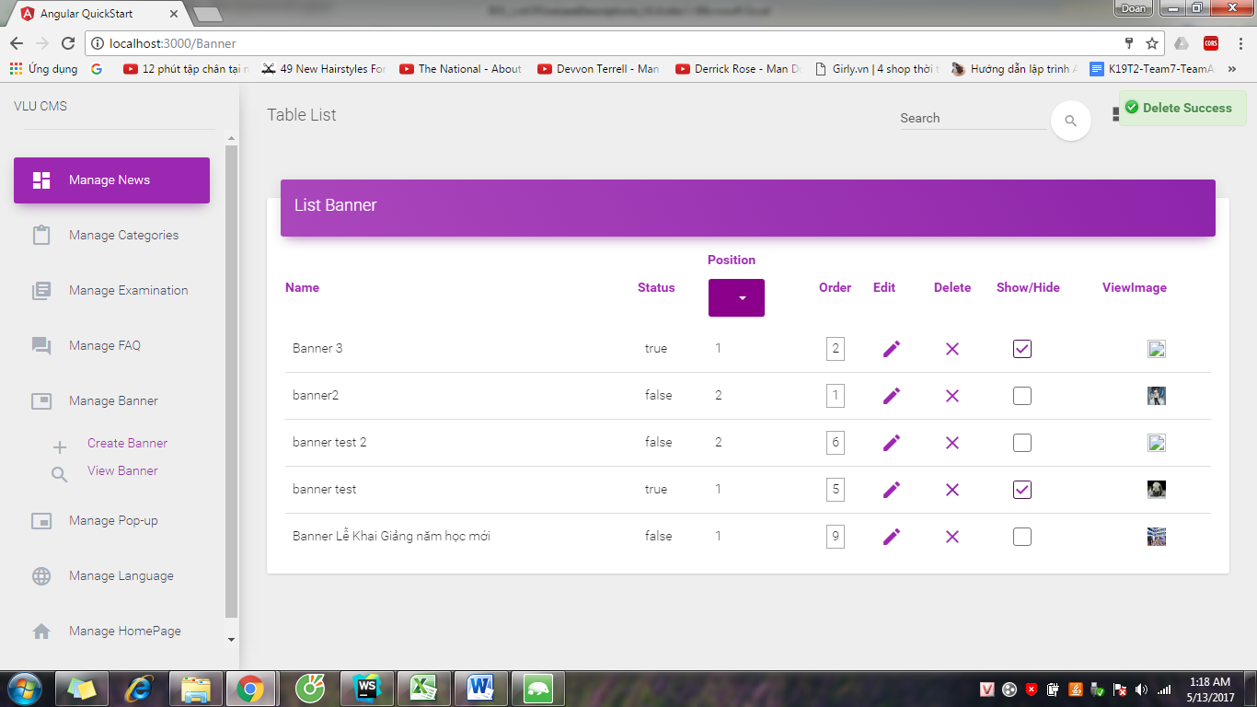

* + 1. Show Banner

Step 1: Login to CMS page by Content Admin account and access to View Banner page



Step 2: Choose banner and check into Show/Hide button.

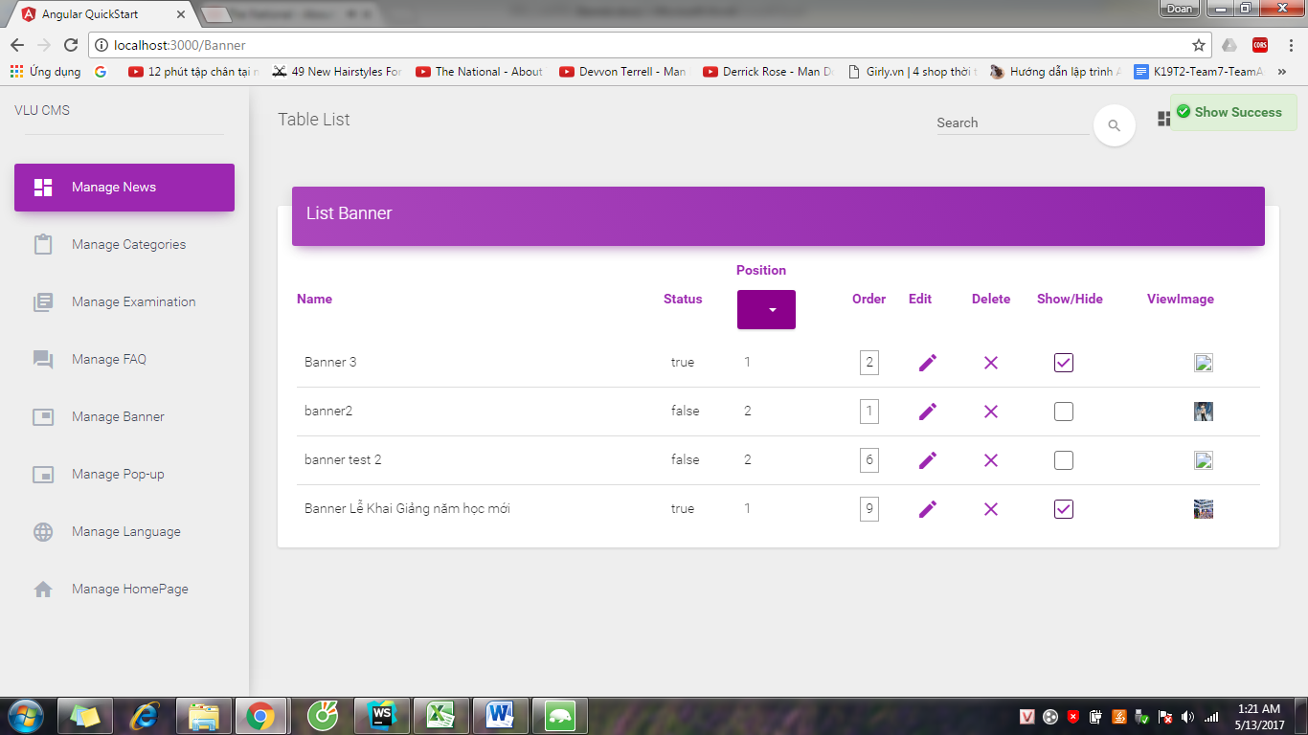

* + 1. Hide Banner

Step 1: Login to CMS page by Content Admin account and access to View Banner page



Step 2: Choose banner and uncheck the Show/Hide button.

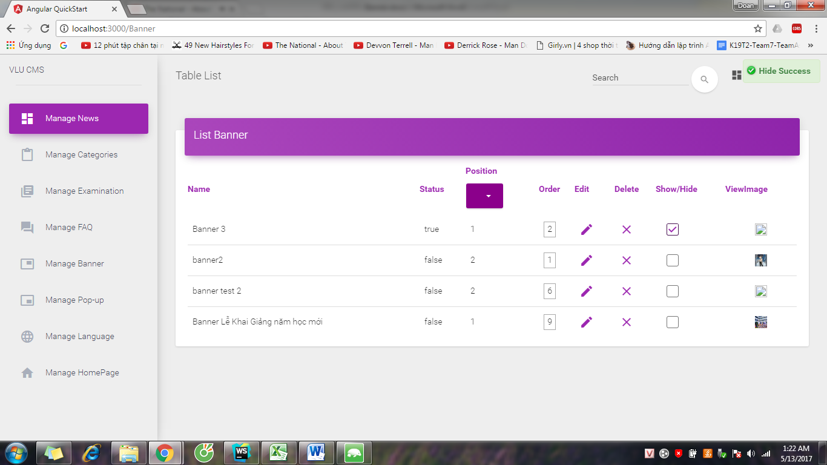

* + 1. Arrange Images

Step 1: Login to CMS page by Content Admin account and access to View Banner page



Step 2: Choose position of banner which you want to arrange images

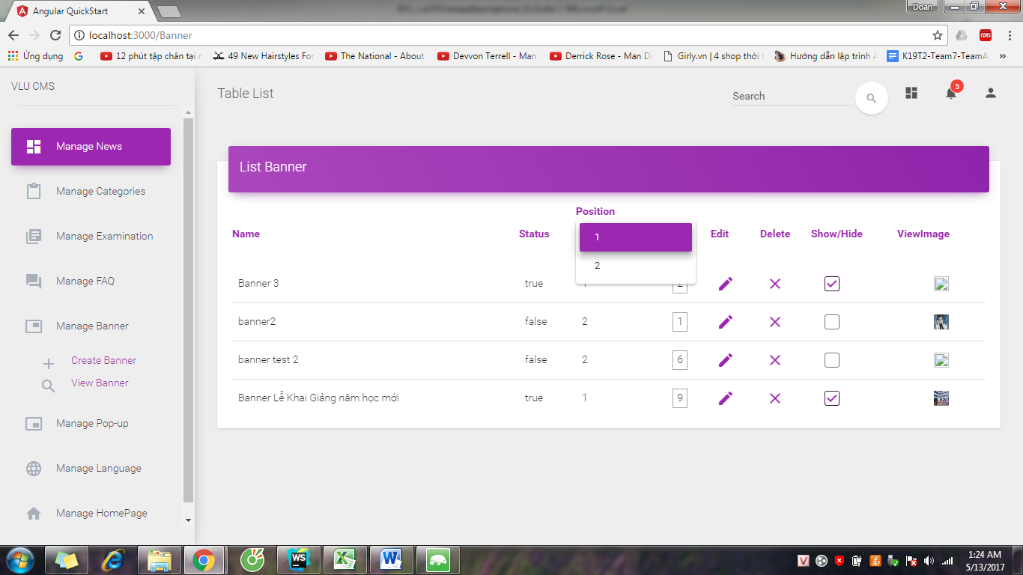

Step 3: System show banner of this position

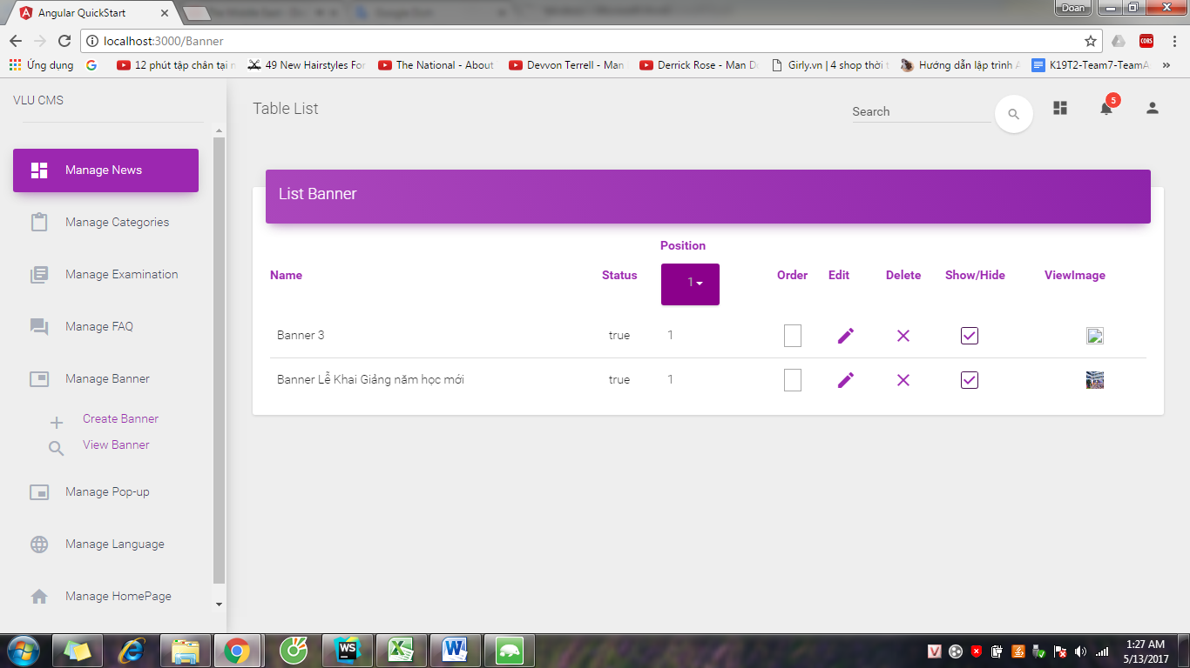

Step 4: Input the number of banner into field Order

